Cellular Goore Game with Multiple Learning Automata in each Cell and its Applications
Mohammad Mehdi Daliri Khomami¹, Ali Mohammad Saghiri² , Mohammad Reza Meybodi^{*3}
Department of Computer Engineering Amirkabir University of Technology, Tehran, Iran
m.daliri@aut.ac.ir
saghiri@aut.ac.ir
mmeybodi@aut.ac.ir
Abstract: Recently, a model known as Cellular Goore Game (CGG) has been introduced, which represents a hybrid approach combining principles from Cellular Automata theory, Learning Automata from reinforcement learning, and Goore Game from game theory. While this model has garnered attention, it has been noted that each cell in the traditional CGG model is equipped with only a single learning automaton, which may not be suitable for certain real-world scenarios. In this study, we aim to enhance the traditional CGG model by introducing multiple learners within each cell, resulting in the proposed model termed CGG-MLA (Cellular Goore Game with Multiple Learning Automatons). We apply this extended model to address the overlapping community detection problem in multilayer social networks, leveraging its optimization capabilities. Additionally, we investigate the temporal behavior of the CGG-MLA using a solution based on Ordinary Differential Equations (ODEs) and conduct a thorough performance analysis to validate its effectiveness. Our experimental results demonstrate that the CGG-MLA-based approach surpasses alternative algorithms, including Pure-Chance-CGG, GenLouv, mInfomap, PMM, CLACD, and MLCD, in terms of metrics such as Normalized Mutual Information (NMI), modularity, MinMaxCut and Coverage, thus highlighting its efficacy in overlapping community detection within multilayer social networks.
Keywords: Cellular Automata, Learning Automata, Goore Game, Cellular Goore Game, Overlapping Community, Multilayer Social networks

Introduction
Cellular automata theory is widely applied in scientific research and simulation as a discrete model. This model consists of simple, identical components known as cells, arranged in a regular grid pattern. Each cell can adopt a state from a finite set of possible states. The operation of a cellular automaton (CA) is governed by a specific local rule, which depends on the cell's immediate surroundings, including itself and its neighboring cells[1]. A configuration represents the global state of a CA, incorporating the states of all constituent cells. CAs adhere to local rules dictating system evolution over time, where interactions between the initial configuration and these rules determine subsequent changes[2]. Notably, CAs are effective for modeling real social systems comprised of vast collections of simple, interacting components. Conceptually, CAs resemble points in a lattice, adhering to a simple local rule and characterized as cellular and automated[3]. This characteristic implies predictable interactions among cells based on their lattice positions, enabling autonomous system operation without centralized control.
However, the learning automaton (LA) serves as a fundamental agent for decision-making in uncertain and stochastic environments. The LA functions as a learning paradigm aimed at selecting an action from its set of possibilities based on feedback from the environment. This model offers the advantage of constructing complex structures using a simple unit, facilitating the design and management of intricate learning tasks[4]. In numerous practical scenarios and applications, local interaction among learning automata (LAs) proves essential. Local interaction involves LAs exchanging information within a defined neighborhood or proximity. Such interaction can be illustrated through various graph structures like trees, meshes, or arrays. Employing a graph-based framework enables LAs to communicate with neighboring automata, allowing for knowledge sharing, action coordination, and collective contribution to decision-making. These local interaction mechanisms enhance the efficiency and effectiveness of the learning automata system, promoting cooperative behavior and optimizing learning outcomes across diverse contexts[5].
Presently, the fusion of cellular automata and learning automata has birthed novel models known as cellular learning automata (CLA). These composite models encompass various criteria, including static and dynamic, open or close, synchronicity or asynchronicity, as well as the configuration of either a singular or multiple automata within each cell. Static Cellular Learning Automata (SCLAs) constitute one class, wherein the cellular structure of the CLA remains constant throughout its evolution. Many CLAs, including those documented in [6] , fall into this category. SCLAs can be further categorized as closed or open. In closed SCLAs, the action of each LA relies on neighboring cells, while in open SCLAs, it depends on neighboring cells, a global environment, and an exclusive environment. SCLAs can also be synchronous or asynchronous. In synchronous SCLAs, all cells employ their local rules simultaneously, assuming the existence of an external clock that synchronizes cellular events[7]. Conversely, in an asynchronous SCLA, only some cells are activated at a given time, while the rest maintain their states unchanged[5]. Additionally, a model of SCLA featuring multiple LAs within each cell was outlined in [8]. Depending on its structure, SCLA can also be classified as regular [2] or irregular[9]. In an Irregular CLA, the assumption of structural regularity is discarded, facilitating its application in solving problems modeled by graphs with irregular structures, as demonstrated in [10] . Dynamic Cellular Learning Automata (DCLAs) form another category, where one or more aspects of the CLA, such as its structure, local rule, or neighborhood, may undergo changes over time. DCLAs can be further divided into closed DCLAs [15], [16] or open DCLAs, based on their operational characteristics. Moreover, DCLAs can be classified as either synchronous or asynchronous. Notably, all documented DCLAs are characterized as closed and asynchronous [13], [14].

The Goore-Game has been extensively studied in the field of artificial intelligence, as discussed in [17]. It has been shown to effectively simulate complex decision-making processes and serves as a benchmark for AI research. Results indicate its capability to accurately predict outcomes based on different strategies, providing valuable insights into AI algorithm performance. Conceptually, envision a large room with N cubicles and a raised platform where a Referee oversees voters in each cubicle, akin to a voting system ensuring fair and accurate voting. Each round involves voters independently casting "Yes" or "No" votes, with the Referee calculating the fraction λ representing the proportion of "Yes" votes. To optimize the system, the Referee uses a uni-modal performance function G(λ) to precisely match the fraction of "Yes" votes to a predetermined value λ*. Following each round, voters receive or lose a dollar based on probabilities determined by G(λ), influencing subsequent voting decisions.
The application of learning processes to cellular networks extends to addressing various real-world issues, particularly those concerning social networks. With this aim, a novel model, the Cellular Goore Game (CGG), is proposed, integrating multiple Learning Automatons (LAs) within each cell. The motivation for employing cellular Goore Game (CGG) structures with multiple learning automata (LAs) in each cell originates from the necessity for enhanced computational capabilities and more adaptable decision-making processes. Through the incorporation of multiple LAs within individual cells, CGGs acquire the capacity to manage complex information more effectively. This configuration enables the simultaneous consideration of diverse factors and strategies, thereby fostering the development of sophisticated and flexible behaviors. Additionally, the interaction among multiple LAs within the same cell promotes collaborative decision-making and enhances the utilization of available information resources. Ultimately, the integration of CGGs with multiple LAs per cell aims to achieve superior performance and resilience in tackling complex problems compared to CGGs equipped with only a single LA per cell. This paper focuses on investigating the behavior of the CGG with multiple LAs in each cell, particularly its steady-state dynamics. The analysis reveals that, under certain conditions, the CGG converges towards a globally stable state. Furthermore, an illustrative application of this innovative model in the context of multilayer overlapping community detection within social networks is presented.
In summary, our contribution can be summarized as follows:
- The Cellular Goore Game with Multiple Learning Automata (CGG-MLA) represents a recent advancement in modeling complex environments, such as social and information networks.
- It extends the naive Cellular Goore Game (CGG) by incorporating multiple learning automata within each cell, providing applicability and adaptivity to the model for solving complex network problems.
- The CGG-MLA opens a new learning paradigm for solving many real problems in online, non-deterministic, dynamic, distributed or decentralized environments such as online social networks, cloud computing, internet of things and Blockchain technologies.
- The convergence behavior of the CGG-MLA model confirms that the algorithm converges to near optimal solution.
- From an application perspective, the proposed model is applied to the problem of detecting multi-layer overlapping communities.
The remainder of this paper is organized as follows: Section 2 provides an overview of related works. Section 3 briefly explains the concept of learning automata. In Section 4, we introduce the definition of Cellular Goore Game with multiple LAs in each cell (CGG-MLA) and discuss its steady-state behavior, convergence behavior, and complexity analysis, respectively. Section 5 defines the application of the CGG with multiple LAs along with some requirements. Section 6 presents the proposed CGG-based algorithm for finding overlapping communities in multilayer networks. Section 8 outlines the evaluation metrics for CGG-MLA. Numerical results are presented in Section 9, and the paper concludes in Section 10.

Related Works
This section provides a short overview of three aspects: first, recent applications of the Cellular Goore Game; second, a learning model based on CLA; and third, the application of overlapping community detection in multi-layer social networks.
Recently, the Cellular Goore Game (CGG) model has been studied extensively across various domains, leading to the development of numerous algorithms based on its framework. In [18], the Cellular Goore Game (CGG), a novel extension of the Goore Game (GG), was introduced to model network problems in domains such as computer networks, grid computing, and social networks. Unlike GG, CGG forms a network of GGs where each node acts as a referee, participating in local GGs with its neighboring players. To showcase the model's potential, the CGG-Clique algorithm was proposed for solving the maximum clique problem in networks. In this algorithm, cells independently select optimal actions based on gains and losses from adjacent referees. The complexity of the CGG-Clique algorithm was analyzed, demonstrating its scalability. Extensive experiments on the DIMACS benchmark validated the algorithm’s effectiveness by comparing it with seven existing methods, highlighting its superiority in efficiently identifying larger cliques. Future work includes introducing new evaluation metrics for CGG behavior and applying the model to identify maximum cliques in multilayer social networks. Ameri et al. [19] studied the CGG model through extensive experiments and demonstrated its applicability by developing two QoS control algorithms for wireless sensor networks (WSNs) with overlapping clusters: one for clustered WSNs and another for WSNs with multiple sinks. These algorithms dynamically regulate the number of active sensor nodes to maintain QoS parameters effectively. The proposed methods were evaluated using ns3 simulations and compared with existing QoS control protocols, including those based on Goore Game models and other approaches. The results indicated that the proposed algorithms outperformed or were comparable to existing methods in terms of QoS performance metrics. In [20], the Cellular Goore Game Consensus Protocol (CGG-CP) was extended to propose an enhanced consensus algorithm, ICGG-CP, aimed at improving fault tolerance and reducing communication complexity. This protocol retains the three primary roles of CGG-CP—referee, player, and owner—but introduces mechanisms to address owner and referee failures. A secondary owner is selected among referees to ensure operational continuity in the event of owner failure, and referee fault tolerance is improved through a reporting mechanism for referee misconduct. To enhance block validation, ICGG-CP uses a weighted average reward system, prioritizing nodes with higher credibility. Additionally, the protocol reduces communication costs by allowing players to inform referees of action convergence, avoiding redundant communication. The study provides a theoretical analysis of the CGG's convergence behavior and demonstrates its effectiveness through comprehensive experiments, which show significant improvements in fault tolerance and communication efficiency. Future work includes methods to accelerate CGG convergence, further reducing communication costs and increasing throughput. The integration of AI techniques, such as outlier analysis and clustering, is also planned to enhance the cognitive engines of the consensus algorithm. Khomami et al. [21] introduced six CGG-based algorithms utilizing learning automata to estimate network measures specific to stochastic multilayer graphs. These algorithms effectively model user behavior dynamics in multilayer networks, offering more accurate representations of relationship complexities and behavioral uncertainties. They also analyze how user behavior influences network measures, enhancing the understanding of social network structures. The proposed framework shows significant potential for applications in online social networks, such as modeling human activity and user behavior. Future research aims to extend these measures and algorithms to broader applications, including multilayer network sampling and identifying influential nodes for viral marketing. In [22], a novel stochastic multilayer shortest path algorithm was proposed, addressing the complexity of analyzing multilayer graphs with stochastic elements. Built upon the CGG framework and leveraging reinforcement learning with learning automata, the algorithm efficiently determines the shortest path between nodes in stochastic multilayer graphs—a task not previously explored with this approach. Each graph cell is equipped with a learning automaton and a referee, which collaborate to optimize the learning process. The automaton performs two actions—designating membership or non-membership in the shortest path—to identify candidate paths. A referee evaluates these paths by calculating their length and expected value, providing reinforcement signals to guide the automaton toward the optimal solution. The algorithm has demonstrated effectiveness across various types of stochastic multilayer graphs, making it applicable to domains such as biology, economics, engineering, and social networks. Its adaptive learning capabilities and ability to function in dynamic environments highlight its potential for advancing our understanding of complex systems and their interdependencies.
A Learning Automaton (LA) is a simple decision-maker designed to learn actions that yield higher rewards. There is a wide array of networks of Learning Automata (LAs) documented in the literature, including DLA[24], eDLA[25], WCLA[26], Adaptive Petri Net[27], and CLA[2], among other structures highlighted in[28]. These publications focus on diverse designs for networks of LAs. We have thoroughly studied all these to underscore the unique stance of our model. The CLA has previously been introduced as a hybrid model in [1] because it encompasses a specific structure of LA that emphasizes the local interactions of cells—a trait common to some Cellular Automata (CA) systems—and operates under a local rule derived from the theories of LAs and CAs. For more clarification, in the revised version for the paper, Figure 1 give a classification on CLAs that has been reported in the literature.
CLAs
Changes
Global Environment
Synchronous activation

Number of LAs

Static CLAs

Dynamic CLAs

Open CLAs

Closed CLAs

Synchronous CLAs

Asynchronous CLAs

CLAs with one LA in each cell

v
CLAs with multiple LAs in each cell

v
Figure 1: A classification of Cellular Learning Automata
Cellular Learning Automata (CLAs) emerge from the fusion of Cellular Automata (CAs) and learning automata (LAs) [2]. CAs are models composed of numerous cells arranged in a lattice structure. In a CA, each cell adopts a state from a finite set of states. The subsequent state of each cell is determined by the prior states of a designated set of cells, encompassing the cell itself and its neighboring cells[29]. In a CLA, every cell within the CA is endowed with a learning automaton to govern its state selection. Within the CLA framework, a local rule, termed as the local rule, dictates the response of each cell's learning automaton. Each cell employs this local rule to elicit the response of its learning automaton, taking into account information pertaining to itself and its neighboring cells. Reported models concerning Cellular Learning Automata (CLAs) can be categorized into two distinct classes, as elucidated below:
Cellular Learning Automata (CLAs) with one LA in each cell, constitute a distinct class, wherein the cellular structure of the CLA comprises one LA per cell. Many CLAs, including those documented in [30], [31], [32], [33], fall into this category. CLAs with one LA can be further categorized as closed or open. In closed CLAs, the action of each LA relies on neighboring cells, while in open CLAs, it depends on neighboring cells, a global environment, and an exclusive environment. CLAs with one LA can also be synchronous or asynchronous. In synchronous CLAs, all cells employ their local rules simultaneously, assuming the existence of an external clock that synchronizes cellular events[1]. Conversely, in an asynchronous CLA, only some cells are activated at a given time, while the rest maintain their states unchanged [5]. In an Irregular CLA with one LA in each cell, the assumption of structural regularity is discarded, facilitating its application in solving problems modeled by graphs with irregular structures, as demonstrated in [38]. Dynamic Cellular Learning Automata (DCLAs) form another variation in which using one LA in each cell, where one or more aspects of the CLA, such as its structure, local rule, or neighborhood, may undergo changes over time. DCLAs can be further divided into closed DCLAs[35] [36]or open DCLAs, based on their operational characteristics. Moreover, DCLAs can be classified as either synchronous or asynchronous. Notably, all documented DCLAs are characterized as closed and asynchronous [35], [37].
A model of CLA featuring multiple LAs within each cell was outlined in [8]. Depending on its structure, CLA with multiple LAs in each cell can also be classified as regular or irregular [38], [39]. Cellular Learning Automata (CLA) with multiple Learning Automata (LA) in each cell represent a variation where multiple LA entities coexist within a single cell. This approach allows for more complex decision-making processes and enhanced adaptability within cellular networks. With multiple LAs, each cell can simultaneously consider and evaluate multiple actions, leading to a richer exploration of the solution space. The interactions between multiple LAs within a cell can introduce dynamics and emergent behaviors that are not present in CLAs with a single LA per cell. This approach has been explored in various contexts, including optimization, network routing, and pattern recognition, where the parallel decision-making capabilities of multiple LAs can lead to more efficient and effective solutions.
In recent years, notable progress has been achieved in learning models and the detection of multilayer overlapping communities. The identification of communities within intricate social networks has garnered substantial scholarly attention owing to its diverse applications. Traditional algorithms like modularity optimization, spectral clustering, or hierarchical clustering can be extended to handle overlapping communities in multilayer networks. Evaluation metrics such as modularity, normalized mutual information (NMI), or F1 score are used to assess the quality of detected communities, comparing them with known ground truth or evaluating internal cohesion and external separation. Post-processing and visualization techniques refine identified communities and remove potential noise, aiding in interpreting and visualizing resulting overlapping communities in multilayer social networks. Mucha et al. [40] introduce Infomap to detect overlapping communities in multilayer networks, revealing dynamic patterns of community organization over time. Jia et al. [41] proposed an algorithm that utilizes trust relationships to transform multilayer social networks into a single-layer trust network by merging overlapping communities. Their experimental results demonstrated improvements in modularity and harmonic mean. In [42], an algorithm employing non-negative matrix tri-factorization is presented to detect communities in multiple heterogeneous networks. This method leverages alignment matrices, yielding enhanced performance on datasets such as Twitter and Instagram. Wang et al. [43] introduced a community detection method for Social Internet of Things (IoT) systems, addressing multiple relationship layers. Their algorithm aggregates communities, resulting in improved success rates in experiments. Similarly, Rani et al. [44] proposed a community detection approach for Social IoT systems, focusing on multilayer relationships. The algorithm aggregates communities and enhances experimental success rates. In [45], a hierarchical algorithm for overlapping community detection using weighted aggregation is developed, achieving higher accuracy and reduced computational costs. Finally, Zhang et al. [46] applied matrix tri-factorization to detect communities in multiplex networks, effectively identifying coherent communities across layers. Huang et al[47] offers an exemplary review of community detection techniques in multilayer social networks and their corresponding applications. They begin by discussing various formats of multilayer networks and introduces two fundamental mathematical models. Then, it reviews quality evaluation measures and several common community detection algorithms, such as label propagation-based algorithms, nonnegative matrix factorization, random walk methods, and multi-objective optimization methods. The analysis suggests that existing methods are primarily designed for multiplex networks, where nodes in each layer are aligned, limiting research on more universal multilayer network formats. Additionally, the algorithms tend to have high computational complexity and struggle to produce meaningful partitions in large-scale multilayer networks. They also explore applications of multi-layer community detection in diverse fields such as social networks, biological networks, and transportation networks. In[48] proposes a novel community detection method tailored for multilayer networks, which considers both intra-layer and inter-layer similarities to construct a dendrogram capturing the network's unique topology and interplay. By introducing a new community density metric, the dendrogram is partitioned to identify overlapping communities accurately. Experimental results on synthetic and real-world datasets demonstrate the effectiveness of the proposed method in discovering overlapping communities in multilayer networks. Huang et al [49] discusses the limitations of existing approaches for detecting overlapping community structures in multi-view networks and introduces a novel method called oComm. This approach incorporates a community membership strength vector for each node in each view to model overlapping community structures and utilizes a network generative model to measure within-view community quality. Additionally, a cross-view community consistency model is established using Jaccard similarity to assess consistency across different views. By solving an objective function through the alternative coordinate gradient ascent method, optimal community membership vectors are generated, allowing for the identification of multi-view overlapping community structures. The effectiveness of the proposed method is demonstrated through comparisons with existing approaches using EEG data from 147 subjects, highlighting its superior performance. In [50] discusses the challenges in community detection within real-life networks, particularly weighted temporal text networks, focusing on modeling edge weights and leveraging temporal information. They stated that existing methods often overlook edge weights or handle them using graph measures like modularity, which lacks scalability. Moreover, temporal information is commonly handled through time discretization, leading to various issues. To address these challenges, the Custom Temporal Community Detection (CTCD) method is proposed, which incorporates a probabilistic generative model to encode edge weight and temporal information. CTCD utilizes network, semantic, and temporal data to extract temporal community affiliations, influence strength, and temporal interests. The method offers efficient inference and parallel implementation to handle large datasets, enabling the identification of individual user community shifts and tracking community development over time. Experimental results on large-scale weighted temporal text networks demonstrate CTCD's significant improvement over existing methods across various tasks. Gupta et al [51] investigated the importance of identifying community structures within growing networks across various domains, emphasizing the need for robust community detection algorithms to reveal disjoint, overlapping, and nested community patterns. To address this, the paper introduces an algorithm for overlapping community detection leveraging granular link information and principles from rough set theory. The algorithm begins by utilizing neighborhood links to create initial link subsets and iteratively computes constrained linkage upper approximations until convergence. These upper approximation subsets are then constrained and merged based on mutual link reciprocity. Experimental results on ten real-world networks validate the effectiveness of the proposed algorithm, as demonstrated through comparative evaluations against state-of-the-art community detection methods. In [52] discusses the complexity of multidimensional networks and the challenges in detecting overlapping communities within them. With the aid of existing methods in which overlook inter-layer interactions and unique topological structures, focusing solely on non-overlapping communities. To address this gap, they proposed a novel approach leverages edge behavior within and between layers to calculate similarities, which are then used to construct a dendrogram capturing both structural and transactional aspects. By introducing a new community density metric, overlapping communities are identified effectively. In [41] introduces a novel algorithm for detecting overlapping communities in multilayer social networks, addressing the issue of lacking user social attribute characteristics during the process. The proposed algorithm utilizes trust relationships by integrating structural trust and social attribute trust, thereby converting the multilayer social network into a single-layer trust network. Community structure is then obtained using a trust-based community discovery algorithm, followed by the merging of communities with higher overlap. Experimental evaluations conducted on synthetic and real networks demonstrate the algorithm's superior performance in terms of harmonic mean and modularity compared to other algorithms of similar nature. In [53] suggests the significance of multilayer complex networks in representing heterogeneous systems, emphasizing their relevance in the era of big data. It highlights the impact of interlayer connections on community structures, making community detection in multilayer networks a crucial research area in data mining. They introduce a modified particle competition model tailored for multilayer network community detection, which can handle weighted and directed networks. Additionally, a localized measure is proposed to determine the optimal number of particles for detecting communities. Computer simulations demonstrate the superior performance of the proposed technique compared to existing methods. In [54] proposes an efficient algorithm for Markov Clustering (MCL) based on the principles of belief propagation. It introduces a novel approach to improve the performance of traditional MCL algorithms by incorporating belief dynamics. The method involves iteratively updating the belief of nodes in the network, leading to faster convergence and better clustering results compared to standard MCL algorithms. They demonstrate the effectiveness of the proposed approach through experimental evaluation on various datasets, showing significant improvements in both speed and clustering accuracy. In [55] explores the dynamics of the Prisoner's Dilemma game on signed networks, drawing from the principles of structural balance theory. It investigates how the evolution of cooperation unfolds in social networks characterized by positive and negative links. Through computational simulations and analysis, the study delves into the impact of various network structures and dynamics on the emergence and sustainability of cooperative behavior among individuals. In [56] presents a method for characterizing fuzzy community structures within link graphs by optimizing likelihood. It introduces a novel approach that leverages the concept of likelihood optimization to identify fuzzy community memberships of nodes in a network. By optimizing a likelihood function, the method assigns soft memberships to nodes, allowing them to belong to multiple communities simultaneously with varying degrees of membership strength. The paper demonstrates the effectiveness of the proposed method through experiments on various real-world networks, showcasing its ability to accurately capture the fuzzy nature of community structures in link graphs.

Table 1: Table of symbols and abbreviations.
$$n_{l_{i}}$$ | The number of LAs that is adjacent to ${cell}_{i}$ and select “Yes” action
$$α$$ | Action Set
$$c$$ | penalty probabilities
$$N$$ | Input network of Cellular Goore Game
$$V$$ | Represent the set of vertices
E | The set of edges
P | The set of player
R | The set of referee
A | The set of learning automata
F | The set of mapping function
$$G$$ | The set of uni-modal performance function
$$x_{i1}\left(t\right)$$ | The probability of selection of first action by learning automaton $i$ at instance $t$.
$$M$$ | Multilayer network
$$G$$ | Set of networks
$$C$$ | Set of edges
L | Number of layer
$$β$$ | Reinforcement signal
$$G_{i}$$ | Uni-modal performance function
$$λ_{i}^{l}$$ | The function that counts number of LAs that select the first action $a_{i1}^{l}$
$$Q^{M}$$ | Multilayer modularity
$$NMI$$ | Normalized Mutual Information
$$θ_{i}^{l}\left(t\right)$$ | The density of community $i$ at iteration $t$.
$$ζ_{i}^{l}\left(t\right)$$ | The sparsity of community $i$ at iteration $t$.
$$K_{i,l}^{in}\left(g\right)$$ | The input degree of node $i$ in layer $l$ to community $g$
$$K_{i,l}^{out}\left(g\right)$$ | The output degree of node $i$ in layer $l$ to community $g$.
$$F$$ | The set of mapping function where F_{i} is associated with cell_{i}.

Learning Automata
The concept of Learning Automata (LA) revolves around the process of randomly selecting an action from a finite set of actions and subsequently executing that selected action within an unknown and stochastic environment. To accomplish this, a probability distribution is employed to randomly choose an action from the given set, which is then utilized as input within the random environment. As a result of the executed action, the environment generates a reinforcement signal in response. The LA then proceeds to update its internal state based on the selected action and the received signal, ultimately determining the subsequent action it should undertake.
The primary objective of a learning automaton is to choose the appropriate action from a set of actions in order to minimize the average penalty it receives from the environment. The learning automaton's environment is described as a triple $E=\{α,β,c\}$, where $α=\left\{α_{1},…,α_{r}\right\}$denotes the set of inputs (action sets), $β=\{β_{1},…,β_{m}\}$ represents the set of possible output values for the reinforcement signal, and $c=\{c_{1},….,c_{m}\}$ signifies the set of penalty probabilities determined by the environment response. $c_{i}$ represents the penalty probability for action $α_{i}$. The environment can be categorized into three distinct types, namely P-model, Q-model, and S-model, based on the characteristics of the reinforcement signal. In a P-model, the reinforcement signal exhibits binary behavior with values limited to 0 and 1. In a Q-model, the reinforcement signal is capable of assuming a finite range of values between 0 and 1. In an S-model, the reinforcement signal is characterized as a continuous random variable that spans the interval [0, 1]. If the probabilities of penalties change with time, the random environment is categorized as nonstationary; otherwise, it is classified as stationary. Figure 2 shows the dynamic interplay between the learning automaton and its corresponding environment. It visually captures the intricate relationship and information flow between these two entities throughout the learning process. By analyzing Figure 2, one can gain a comprehensive understanding of how the learning automaton adapts and responds to the environmental cues and feedback it receives.

Random Environment
Learning Automaton
Environment Response
Selected Action
Evaluation
Reinforcement signal
Figure 2: Learning Automata
The quadruple $α,β,I,X(t)$, is defined as a representation of the Learning Automata (LAs), where$α$ indicates a finite set of actions denoted by $α=\{α_{1}.….α_{r}\}$, $β$ stands for the set of all possible inputs or reinforcements signal for the LAs, $I$ represents the learning algorithm responsible for updating the action probabilities, and $X(t)$ describes the action probability vector at a given time t. The action probability vector is adjusted by the learning algorithm through the use of a recurrence relation.
$$X_{i}\left(t+1\right)=X_{i}\left(t\right)+a\left(1-X_{i}\left(t\right)\right)$$ | (1)
$$X_{j}\left(t+1\right)=X_{j}\left(t\right)-aX_{j}\left(t\right) ∀j≠i$$ | (1)

$$X_{i}\left(t+1\right)={(1-b)X}_{i}\left(t\right)$$ | (2)
$$X_{j}\left(t+1\right)=\frac{b}{r-1}+(1-b)X_{j}\left(t\right) ∀j≠i$$ | (2)

At instance t, a learning automaton selects action $α_{i}$ from distribution $X(t)$. In a linear learning algorithm, equation (1) determines the updating of probability vector $X(t)$ for a favorable response (β=1), and equation (2) for an unfavorable response (β=0). The probability of receiving an unfavorable response for action $α_{i}$ is represented by $c_{i}=Pr⁡[β=0|α_{i}]$.

Figure 3: Pseudocode of a learning automaton and its policy.
The probabilities of receiving a favorable or unfavorable response by the LA are not known. The parameter a determines the extent to which the action probability vector increases, while the parameter b determines the extent to which it decreases. Equations (1) and (2) are referred to as ($L_{R-P}$) when $a$ equals $b$, ($L_{R-εP}$) when $a$ is much greater than b, and $L_{R-I}$ when $b$ is equal to zero. In $L_{R-I}$, the action probability vectors remain unchanged despite penalization by the environment. Figure 3 provides the pseudo code of a learning automata and its policy in algorithmic shape.

Learning has become a vital optimization tool in complex and dynamic environments with significant uncertainty or limited environmental knowledge. Numerous instances of successful integration of learning automata can be found across various domains, including graph problems [57], Petri net[58], image processing[59], Internet of Things [60], cloud computing [61], wireless sensor networks[62], p2p networks[63] and complex networks[64].

Cellular Goore-Game with multiple LAs (CGG-MLA)
This section starts by defining the Cellular Goore Game with Multiple Learning Automata (CGG-MLA). It then proceeds to explain the updating process of CGG, followed by a description of two evolution metrics used to analyze this process. Moreover, Table 1 provides notations applied for CGG-MLA.

The Definition of CGG with multiple LAs
The CGG with multiple LAs in each cell is network of GG in which each cell comprises several LAs. This model can be formally defined by 6 tuples as follows:
Definition 1. A Cellular Goore Game(CGG) with multiple LAs can be defined by 6-tuple
CGG = (N, P, R, A, F, G), where
- The input network, denoted as $N = (V, E)$, represents the structure of CGG. Here, $V$refers to a set of vertices represented by $\{{cell}_{1}.{cell}_{2}.….{cell}_{n}\}$, and $E$ represents the set of edges.
- P= {P₁, …, P_{n}} where P_{i} is a subset of players assigned to cell_{i}.
- R= {R₁, …, R_{n}} comprises as a subset of V playing the role of referees.
- A = {A₁, A₂, … A_{n}} is a set of LAs where $A_{i}=\{{LA}_{ij} | \{i,j\}∈E\}$ is the set of learning automaton residing in cell_{i} and each learning automaton has two actions “Yes” or “No”.
- F = {F₁, F₂, … F_{n}} is the set of mapping function where F_{i} is associated with cell_{i}. The function F_{i} takes the set of index of neighbors and assign its corresponding learning automata in that cell. For example, if cell_{j} is the neighbor of the cell_{i} then ${LA}_{ij}$assign to cell_{i.}
- $G$ = ($G_{1}$, $G_{2}$, …$G_{n}$) determine a set of unimodal performance criteria for the referees, where G_{i} is the performance criterion for cell_{i}.
1
2
3
4
5
$${LA}_{14}$$
$${LA}_{13}$$
$${LA}_{12}$$
$${LA}_{31}$$
$${LA}_{25}$$
$${LA}_{21}$$
6
7
8
9
10
11
12
13
14
15
16
17
$$R_{2}$$
$$R_{3}$$
$$R_{1}$$
$$R_{4}$$
$${LA}_{41}$$
$${Cell}_{4}$$
$${Cell}_{1}$$
$${Cell}_{2}$$
$${Cell}_{3}$$
Figure 4: System model of Cellular Goore Game with multiple LAs in each cell by relying on the microscopic view of the cell₁ and its neighborhood structure.
A Cellular Goore-Game with multiple LAs is a connected structure in which each cell contains multiple LAs and each LA has two action within each cell as similar as GG. In this model each cell contains a set of learning automata. Moreover, each cell has a referee to evaluate the selected action by LA’s. The number of LAs which are resided in a cell is equal to the number of neighbors that cell.
Figure 4 illustrates the system configuration of the Cellular Goore Game with multiple Learning Automata (LAs) in each cell, focusing on the microscopic perspective of cell₁ and its neighborhood structure. In this model each LAs may be activated synchronously or asynchronously. In contrary to original GG, exist a mapping function $F$ to generate LAs for a cell and each referee has its own players to playing GG. Let ${cell}_{j}$ is adjacent to ${cell}_{i}$, then the mapping function $F$ takes a learning automaton and return a learning automaton ${LA}_{ij}$ in cell $i$ and a learning automaton ${LA}_{ji}$ in cell $j$ simultaneously. Based on the output of the mapping function $F$ a set learning automaton is obtained for each cell. Figure 3 shows the initial local structure of cell₁ and its neighborhood cells, which contains a set of learning automata and a referee in each cell. The operation of CGG with multiple LAs take place in a discrete time steps. Let $α_{i1}$and $α_{i2}$ are the first and second actions of automaton ${LA}_{ij}$ respectively. Moreover, $p_{ij}(t)=[ p_{i1}\left(t\right),p_{i2}\left(t\right)]$ is the probability of first and second action of ${LA}_{ij}$. At round $t$ of the game, each ${LA}_{ij}$ selects one of its action $α_{ij}\left(t\right)$ from two available actions. After the action selection, each LAs send the selected action to its corresponding referee concurrently. Let ${LA}_{ij}$ is a learning automaton that resided in cell_{i}, after the action selection is done, the learning automaton send its selected action for the referee $R_{j}$. The referee $R_{j}$ receives the selected actions from all current neighboring cell and computes the fraction of LAs that select its first action to the total number of LAs participate in GG for that cell. Let $λ_{j}$ is the fraction of LAs that select its first action. Then, based on the value of performance criteria $G_{j}(λ_{j})$ referee $R_{j}$, each LAs generates a random number in order to reward or penalized of selected action based on learning algorithm. Based on the performance criteria, if each of the Learning Automata (LAs) selects the first action and the generated random number is less than the performance criteria value, then the first actions of all LAs are rewarded. Likewise, if the selected action is the second one and the random number is less than the performance criteria value, then the second actions of all LAs are rewarded. Figure 5 shows the action selection by LAs that associated to cell₁ and generate reinforcement signal by referee $R_{1}$.

Remark 1: The number of LAs resided in each cell corresponds to its direct neighbor degree.
$${LA}_{21}$$
$${LA}_{41}$$
$${LA}_{31}$$
$$R_{1}$$
$$Yes$$
$$α_{1}$$

$$No$$

$$Yes$$

$β$
$${LA}_{14}$$
$${LA}_{13}$$
$${LA}_{12}$$
$${LA}_{31}$$
$${LA}_{25}$$
$${LA}_{21}$$
$$R_{2}$$
$$R_{3}$$
$$R_{1}$$
$$R_{4}$$
$${LA}_{41}$$
$${Cell}_{4}$$
$${Cell}_{1}$$
$${Cell}_{2}$$
$${Cell}_{3}$$
Reinforcement Signal Calculation
Figure 5: The structure of Cellular Goore Game with Multiple LAs (CGG-MLA)

For enhanced clarity, Figure 6 illustrates the flowchart depicting the operation of CGG with multiple LAs.
Start
Initialization
Cellular Goore Game with Multiple Learning Automata Process
Assign to each ${cell}_{i}$ a referee $R_{i}$
Compute degree of each cell
Assign to each ${cell}_{i}$ a learning automaton based on the mapping function $F_{i}$ $Type equation here.$
Assign $\frac{1}{2}$ percent probability as initial value to each learning automaton
$α_{ij}←$ Each ${LA}_{ij}$ selects one of its action based on its action probability vector
$λ_{j}←$ Each referee$j$ count and compute its number of players that select “Yes” over total number of players.
$β_{j}←$ Compute for each referee$j$ a uni-modal performance function $G_{j}( λ_{i})$ and generate reinforcement signal.
$r_{ij}←$ Each ${LA}_{ij}$generates a random number
$r_{ij}< G_{j}( λ_{i})$
No
Yes
If the selected action by ${LA}_{ij}$ is the first action
${LA}_{ij}$ updates its first action of LAs based equation (1)
Yes
${LA}_{ij}$ updates its second action of LAs based equation (1)
No
Stopping condition is met?
Yes
END
No
Figure 6: Flowchart of the CGG-MLA

Convergence behavior of CGG with multiple LAs
In this section, we assume that the following assumptions hold for each ${cell}_{i}$ of the CGG-MLA. Subsequently, we delve into the behavior of the CGG in the remainder of this section.
Definition 1: The configuration of the CGG-MLA with multiple LAs at iteration $t$ is denoted by $\underline{X}\left(t\right)=(X_{1}\left(t\right),X_{2}\left(t\right),…,X_{n}\left(t\right))$ where $X_{i}\left(t\right)$ represents the action probability vector of learning automaton $A_{i}$.
Definition 2: A configuration $\underline{X}$is referred to as deterministic when the action probability vector of all LAs forms a unit vector. Conversely, when the action probability vector deviates from being a unit vector, it is referred to as probabilistic. Hence, we define two sets: $K^{*}$, representing the set of all deterministic configurations, and $K$, representing the set of probabilistic configurations. $K^{*}$ is defined as follows:$K^{*}=\{ \underline{X}|x_{iy}∈\{0.1\}∀y.i\}$. On the other hand, $K$ is defined as: $K=\{ \underline{X}|x_{iy}∈[0.1]∀y.i\}$, where $\sum_{y=1}^{2}{x_{iy}}=1$.
Definition 3: The dynamics of the CGG are described by a mapping $G:K→K$, which represents the global behavior of CGG with multiple LAs.
Definition 4: The evolution of the CGG with multiple LAs from a given initial configuration $X\left(0\right)∈K$ is a sequence of interpolated process ${\{\underline{X}\left(t\right)\}}_{t≥0}$, such that $\underline{X}\left(t+1\right)=aΘ\left(\underline{X}\left(t\right)\right)+ \underline{X}\left(t\right)$.
Our focus will be on investigating the asymptotic behavior of CGG, where the $L_{R-I}$ learning algorithm is employed by all learning automata. The process ${\{\underline{X}\left(t\right)\}}_{t≥0}$, evolutions based on the $L_{R-I}$ learning algorithm can be describe by the following differential equation:
$$\underline{X}\left(t+1\right)=\underline{X}\left(t\right)+\underline{a}.Θ(\underline{X}\left(t\right).\underline{β}\left(t\right))$$ | (3)
Definition 5: Let $ΔX_{i}(t)$ indicates as the conditional expectation of $X_{i}(t)$ and be defined as follows:
$$ΔX_{i}\left(t\right)=E[X_{i}\left(t+1\right)-X_{i}(t)|X\left(t\right)]$$ | (4)
Equation (4) is applied to study the asymptotic behavior of the $X_{i}\left(t\right)$ in the expected sense.
Definition 6: Let $P(ΝE\left(i\right).i)$ be the finite sub set of LAs that does not contain $i$ and defined as follows:
$$P\left(ΝE\left(i\right).i\right)=\{{LA}_{j}|∀j:(i.j)∈E\}$$ | (5)
Additionally, $ψ\left(P\left(ΝE\left(i\right).i\right)\right)$ indicates the subset node form $P\left(ΝE\left(i\right).i\right)$LAs and is defined as follows:
$$ψ\left(P\left(ΝE\left(i\right).i\right)\right)=\{W:W⊆P\left(ΝE\left(i\right).i\right)\}$$ | (6)
Assumption 1: The reinforcement signal $β_{i}(t)$ is non-negative and bounded. For the sake of generality, we assume, $β_{i}∈[0.1]$.
Assumption 2: The expected value of $G_{i}$:$\left[0.1\right]→[0.1]$ is continuous for $∀i∈N$. This continuity is essential as $G_{i}$ should not exhibit discontinuities for any given number of players..
Assumption 3: The referee function $G_{i}$ for $∀i∈N$ is a unimodal function which is computes by equation (7).
$$E\left[β_{i} | n_{l_{i}}\right]=G_{i}(\frac{n_{l_{i}}}{{|NE}_{i}|})$$ | (7)
Where $n_{l_{i}}$ is the number of LAs that is adjacent to ${cell}_{i}$ and select “Yes” action.
Assumption 4: In CGG with multiple LAs, there are not isolated learning automaton that do not participate in action selections in each iteration.
Assumption 5: In CGG with multiple LAs, all referees use same unimodal performance function to generate reinforcement signals.
Hence, the probability of choosing the first action and the second action $k$ times is given by:
$$\operatorname{Pr}\left(n_{k}\left(t\right)=k | X.α_{i}\left(t\right)=α_{i1}\right)=\sum_{W∈P\left(ΝE\left(i\right).i\right);\left|W\right|=k-1}{(\prod_{m∈W}{x_{m1}(t)}}\prod_{n∈ψ\left(ΝE\left(i\right).i\right)-W}{(1-x_{n1}(t))}$$ | (8)
And
$$\operatorname{Pr}\left(n_{k}\left(t\right)=k | X.α_{i}\left(t\right)=α_{i2}\right)=\sum_{W∈P\left(ΝE\left(i\right).i\right);\left|W\right|=k}{(\prod_{m∈W}{x_{m1}(t)}}\prod_{n∈ψ\left(ΝE\left(i\right).i\right)-W}{(1-x_{n1}(t))}$$ | (9)

Since $\{X(t):t>0\}$ is Markovian and $\underline{β}(t)$ depends only on $X(t)$ and not on $t$, then $∆x_{i}$ can be expressed as follows:
$$∆x_{i}=bH_{i}\left(X\right)$$ | (10)
Hence from equation (10) for each ${cell}_{i}$, $∆x_{i}$ is computed by equation (11):
$$∆x_{i}=E\left[x_{i}\left(t+1\right)-x_{i}\left(t\right) | X\right]$$ | (11)
Assume the independence of$x_{i}\left(t+1\right)$ from $x_{i}\left(t\right)$, equation (11) is replaced with equation (12):

$$∆x_{i}=E\left[x_{i}\left(t+1\right) | X\right]-x_{i}\left(t\right)$$ | (12)

Furthermore, by substituting $L_{R-I}$ learning algorithm into equation(12) we derive equation (13):

$$∆x_{i}=x_{i1}+x_{i1}\left[aE\left[β | α_{i}=α_{i1}.X\right]\right]\left[1-x_{i1}\right]+ x_{i2}\left[-aE\left[β | α_{i}=α_{i2}.X\right]x_{i1}\right]-x_{i1}$$ | (13)

After some mathematical manipulation, equation (13) is transformed into equation (14)

$${∆x_{i}=x}_{i1}+ax_{i1}\left[1-x_{i1}\right]\left[aE\left[β | α_{i}=α_{i1}.X\right]\right]-a x_{i1}\left(1-x_{i1}\right)\left[aE\left[β | α_{i}=α_{i1}.X\right]\right]-x_{i1}$$ | (14)
Applying assumption (3) to equation (14) yields equation (15):
$$∆x_{i}=ax_{i1}\left(1-x_{i1}\right)E\left[β | α_{i}=α_{i1}.X\right]-ax_{i1}\left(1-x_{i1}\right)E\left[β | α_{i}=α_{i2}.X\right]=ax_{i1}\left(1-x_{i1}\right)H_{i}(X(t))$$ | (15)

Utilizing assumption (3) in equation (14), we substitute $E\left[β | α_{i}=α_{i1}.X\right]$ with equation (14) and $H_{i}(X)$ is calculated using equation (16)
$$H_{i}\left(X(t)\right)=A_{i}\left(X(t)\right)+B_{i}\left(X(t)\right)$$ | (16)

Where $A_{i}\left(X(t)\right)$ is obtained by equation (17)
$$A_{i}\left(X(t)\right)=\sum_{k=0}^{n-1}{G_{k+1}×}\left(\sum_{W∈P\left(ΝE\left(i\right).i\right);\left|W\right|=k}{\left(\prod_{m∈W}{x_{m1}(t)}\prod_{n∈S\left(ΝE\left(i\right).i\right)-W}{(1-x_{n1}(t))}\right)}\right)$$ | (17)

And $B_{i}\left(X\right)$is obtained by equation (18)
$$B_{i}\left(X(t)\right)=-\sum_{k=0}^{n-1}{G_{k}×}\left(\sum_{W∈P\left(ΝE\left(i\right).i\right);\left|W\right|=k}{\left(\prod_{m∈W}{x_{m1}(t)}\prod_{n∈S\left(ΝE\left(i\right).i\right)-W}{(1-x_{n1}(t))}\right)}\right)$$ | (18)

After some mathematical simplification, equation (15) can be derived as equation (19):
$$H_{i}\left(X(t)\right)=\begin{matrix}\underbrace{\sum_{k=0}^{n-1}{\left(G_{k+1}-G_{k}\right)}} \\ 1\end{matrix}\left(\begin{matrix}\underbrace{\sum_{W∈P\left(ΝE\left(i\right).i\right);\left|W\right|=k}{\left(\prod_{m∈W}{x_{m1}(t)}\prod_{n∈S\left(ΝE\left(i\right).i\right)-W}{\left(1-x_{n1}(t)\right)}\right)}} \\ 2\end{matrix}\right)$$ | (19)

In equation (17) and (18), when $t→∞$, the probability of LAs choosing the first action converges to unity. Therefore, using equations (19), we obtain:
$$\lim_{t→∞}{x_{m1}\left(t\right)=1}$$ | (20)
And at the same time
$$\lim_{t→∞}{x_{n1}(t)=1}$$ | (21)
By utilizing the outcomes of equations (18) and (19), the second part of equation (19) approaches the sum of the product of the probabilities to 1, leading to the derivation of equation (22).
$$H_{i}\left(X\right)=\sum_{k=0}^{n-1}{\left(G_{k+1}-G_{k}\right)}$$ | (22)
Definition 7: Let $u_{ij}$be initially defined as a real value within the range $u_{ij}∈(0,1)$ where $j∈\{1,…,$.${|NE}_{i}|\}$ indicates the neighborhoods for cell_{i}. Moreover, $U_{i}$ is defined as a vector $U_{i}={[u_{ij}]}_{1×|{NE}_{i}|}$ for each cell_{i}. Additionally, for each cell_{i}, the initial value of $H_{i}\left(U_{i}\right)$ is set to zero because we consider $G_{k+1}$ to be equal to $G_{k}$ in the first part of the equation (19), denoted as zero.
Definition 8 : Let $k$ represent a combination of solutions for each cell_{i} of the CGG, with the matrix $U=[U_{1},…,U_{n}]$. For each cell_{i} $\frac{dU_{i}}{dk}= k_{i}\left(U_{i}\right)$, where:
$k_{i}\left(U_{i}\right)=u_{ij}(1-u_{ij})H_{i}\left(X\right)$ $j∈\{1,…,$.${|NE}_{i}|\}$ | (23)
Lemma 1: The maximum value of equation (23) is attained by solving $\frac{dk_{i}\left(U_{i}\right)}{dk}=0$.
Proof: It is an optimization problem, and to finding the maximum value, we need to compute the derivative with respect to $k$ $ADDIN ZOTERO_ITEM CSL_CITATION \{"citationID":"YWG5v8jZ","properties":\{"formattedCitation":"[65]","plainCitation":"[65]","noteIndex":0\},"citationItems":[\{"id":2242,"uris":["http://zotero.org/users/local/8HkWoD71/items/FWQC5SDM"],"itemData":\{"id":2242,"type":"book","publisher":"Research \& Education Assoc.","source":"Google Scholar","title":"AP® Calculus AB \& BC Crash Course Book+ Online","author":[\{"family":"Rosebush","given":"Joan"\}],"issued":\{"date-parts":[["2016"]]\}\}\}],"schema":"https://github.com/citation-style-language/schema/raw/master/csl-citation.json"\} [65]∎$.
In CGG with multiple LAs (CGG-MLA), each cell plays GG with its own environment simultaneously. Therefore, to examine the convergence behavior of CGG with multiple LAs in each cell, we analyze the convergence behavior of individual cell.
Theorem 3: Considering all assumptions for CGG with multiple LAs, equation (24) is satisfied for each specific cell such as cell_{i}.
$$MAX F\left(x_{i}\right)=\sum_{i=1}^{|{NE}_{i}|}{E\left[β_{i} | x_{i}\right]}$$ | (24)
Subject to:
$$\sum_{i=1}^{|{NE}_{i}|}{\sum_{j=1}^{r}{x_{ij}}=1}$$ | $$r=1,2$$  $$i=1,…n$$
$${0≤x}_{ij}≤1$$ | $$∀i,j$$
Where $F\left(x_{i}\right)$ is the function that takes the probability vector of $x_{i}$ and generates the reinforcement signal $β_{i}$.
Proof: To proof this theorem, using lemma 1, the problem reduces to the classic GG, where we have:
$$\frac{dU_{i}}{du_{ij}}=u_{ij}\left(1-u_{ij}\right)\frac{k_{i}\left(U_{i}\right)}{du_{ij}} if j≠i$$ | (25)

$$\frac{dU_{i}}{du_{ij}}=\left(1-{2u}_{ij}\right)k_{i}\left(U_{i}\right) if j=i$$ | (26)
The only stable point of CGG is obtained when the eigenvalues of the matrix$\frac{dU_{i}}{du_{ij}}$ is negative, where$1≤i≤{|NE}_{i}|$ and $1≤j≤{|NE}_{i}|$ . For each cell_{i}, we consider $|{NE}_{i}|$ bit binary strings, with $u_{ij}∈\{0,1\}$, for all $j$which are neighborhood of $i$. Therefore, we have:
$$\frac{dU_{i}}{du_{ij}}=0; for all j≠i$$ | (27)
And for $j$which is equal to $i$.
$$\frac{dU_{i}}{du_{ij}}=\left\{\begin{matrix}k_{i}(u_{ij}) & if u_{ij}=0 \\ -k_{i}(u_{ij}) & if u_{ij}=1\end{matrix}\right.$$ | (28)
Consider a solution string with $k$ ones, with$u_{ij}$ is equal to one when $i=j$. For this combination, it is easy to verify from equation (23) that,
$$\frac{dU_{i}}{du_{ij}}=-(G_{k}-G_{k-1})$$ | (29)
Similarly, if there are $k$ ones where $u_{ij}$ equals zero when $i=j$.
$$\frac{dU_{i}}{du_{ij}}=-(G_{k+1}-G_{k})$$ | (30)
Hence for such a string, the matrix $\frac{dU_{i}}{du_{ij}}$ becomes a diagonal matrix with $-(G_{k}-G_{k-1})$ for $l$ diagonal entries and $-(G_{k+1}-G_{k})$ for $\left(n-1\right)$ diagonal entries. Therefore, only for the value of $k$ as indicated in remark 3, both eigenvalues are negative. Consequently, only those solutions containing $k$ ones are asymptotically stable[66].
Proposition 1: In CGG with multiple LAs, the maximum expected value of reinforcement signals is obtained using equation (31):
$\hat{θ}=argmax F(X)$ | (31)
Where $F(X)$ represents the total estimation of reinforcement signals. Based on assumption 3, in each cell, the referee utilizes the unimodal performance function to generates reinforcement signal. Hence, equation (31) for each ${cell}_{i}$ may be equivalent by equation (32):

$F\left(X\right)=\underset{X_{i}∈X}{argmax}{F(X_{i})}$ $i∈\{1,…,n\}$ | (32)

Equation (32) implies that total expected value by CGG-MLA is equivalent to the maximum expectation $β_{i}$ for each ${cell}_{i}$, which can be rewritten as equation (33):
$$F\left(X_{i}\right)= E\left[β_{i} | X_{i}\right]$$ | (33)
Proof: Since the proposed model employs the same unimodal functions in each cell, the problem is thereby simplified as the expected maximization for a cell. To clarify further, maximizing the expected value of the proposed algorithm merely requires optimizing the unimodal performance function for a cell. In the following theorem, we provide a proof sketch demonstrating that CGG-MLA converges to a unit vector.
Theorem 4: In CGG with multiple LAs, if the learning algorithm is $L_{R-I}$, the entropy, denoted by $Z$, approaches zero as follows:
$$Min Z(t)=\sum_{i=1}^{|n|}{\sum_{j=1}^{{|NE}_{i}|}{x_{ij}(t)\log_{2}{x_{ij}}(t)}}$$ | (34)
Subject to:
$$0{≤x}_{ij}(t)≤1$$  $$\sum_{j=1}^{{|NE}_{i|}}{\sum_{l=1}^{2}{x_{jl}(t)}=1}$$  $$x_{ij}(t)=\{0,1\}$$ | $i,j=1,..,N$ (35)  $j=1,..,N$ (36)  $$l=\{1,2\}$$  $x_{ij}=\{0,1\}$ (37)
In (34) Z(t) is total entropy of the CGG with multiple LAs, where $x_{ij}$ is the action probability vector of the learning automaton residing in ${cell}_{i}$, and ${cell}_{i}$ is adjacent to ${cell}_{j}$. Moreover, ${NE}_{i}$ is defined as the number of adjacent cells for a ${cell}_{i}$.
Proof: As a result of equation (17) and (18), when $t→∞$, $x_{ij}$ tends toward a unit vector. Therefore, by taking the limit of $Z(t)$, we obtain equation (38)
$$\lim_{t→∞}{Z\left(t\right)= \lim_{t→∞}{\sum_{i=1}^{|n|}{\sum_{j=1}^{{|NE}_{i}|}{x_{ij}(t)\log_{2}{x_{ij}}(t)}}}}$$ | (38)
After some mathematical manipulation of equation (38), equation (39) is obtain:
$$\lim_{t→∞}{\sum_{i=1}^{|n|}{\sum_{j=1}^{{|NE}_{i}|}{x_{ij}(t)\log_{2}{x_{ij}}(t)}}}=\sum_{i=1}^{|n|}{\lim_{t→∞}\sum_{j=1}^{{|NE}_{i}|}{{ (x}_{ij}(t)\log_{2}{x_{ij}}(t))}}$$ | (39)
Based on the limit theorem and using the associative property, equation (39) is transformed into equation (40):
$$\sum_{i=1}^{|n|}{\lim_{t→∞}\sum_{j=1}^{{|NE}_{i}|}{{(x}_{ij}(t)\log_{2}{x_{ij}}(t))=}} \sum_{i=1}^{|n|}{\sum_{j=1}^{{|NE}_{i}|}{{\lim_{t→∞} (x}_{ij}(t)\log_{2}{x_{ij}}(t))}}$$ | (40)
When $t→∞$,the action probability of LAs falls into two cases. In case 1, the action probability of learning automaton approaches to one; thus, for this scenario, by substituting the value of $1-ε$, where $ε$ is close to zero, equation (41) is approximated.
$${\lim_{x_{ij}\left(t\right)→1-ε} (x}_{ij}(t)\log_{2}{x_{ij}}(t))= 0$$ | (41)
In case 2, the action probability of learning automaton approaches to zero; therefore, by substituting the value of $0+ε$, where $ε$ is close to zero, equation (42) is approximated.
$${\lim_{x_{ij}\left(t\right)→0+ε} (x}_{ij}(t)\log_{2}{x_{ij}}(t))=0$$ | (42)
From equation (39) and (40) the obtained result for theorem 4 is straight forward.$∎$

Complexity Analysis
From a computational complexity perspective and in terms of space complexity, consider a scenario where the maximum and minimum degrees of the graph are both equal to n-1 and 1, respectively. Consequently, in the worst-case scenario, for a graph with n memory cells, a total of $n^{2}-n$LAs are required, whereas in the best case, only $n$ LAs suffice. Given that each automaton possesses a single probability vector containing two actions, it becomes feasible to store this probability vector using a single memory unit and derive the second probability through subtraction from one. Hence, the CGG-MLA algorithm demonstrates a time complexity of $O(n^{2})$in the worst case and $O\left(n\right)$in the best case. However, when considering time complexity, it primarily revolves around the LAs response to environmental stimuli and the learning rate influencing convergence. Determining the optimal learning rate remains an ongoing challenge in automaton theory[28]. In the context of the CGG-MLA model, the interplay between the behaviors of multiple LAs complicates this matter, rendering it a complex problem without a precise optimal solution. Addressing this challenge is identified as a potential avenue for future research.

Applications: An algorithm for overlapping community detection in multilayer social networks.
This section introduces a novel algorithm, CGG-OCD, based on Cellular Goore Game, designed to address overlapping community detection in multilayer social networks. The CGG-OCD algorithm operates locally and independently, with each cell making decisions autonomously. Additionally, the algorithm is fully distributed, ensuring it avoids local optima. The objective of this research is to explore the potential of employing Cellular Goore Game with multiple learning automata per cell for efficient community detection. To achieve this objective, we outline the algorithm's structure.
Definition 9: A multilayer network $M$ is defined as $M=(G,C)$, where $G=\left\{G_{i}\right|i∈\left\{1,2,…,L\right\}\}$ represents the set of networks, with $|L|$ denoting the total number of layers. Each, $G_{i}=(V_{i},E_{i})$ denotes a network in layer $i$, where $G_{i}$ is termed the layer of $M$. Furthermore, $C=\{E_{ij}⊆V_{i}×V_{j}:i,j∈\left\{1,2,….,L\right\}, i≠j\}$ represents the set of interconnections between nodes across different layers $G_{i}$ and $G_{j}$, where $i≠j$. The edges within the $E_{i}$ set are known as intra-edges. Elements of $C$ are referred to as crossed layers, while elements of each $E_{i}$ are termed interlayer edges of $M$, in contrast to $E_{ij}$, which are termed cross-layer edges.
Definition 10: The set of communities, denoted as $S=\{C_{1},C_{2},…,C_{m}\}$, comprises individual communities represented by $C_{i}=(g ,l)$, where $g$ is a subset of $G$ and $l$is a member of $|L|$. In order to establish a formal definition for multilayer communities, we have expanded upon the definition provided in [67] for simple networks.
Definition 11: A multilayer strong community refers to a group of nodes where, in each layer, the internal degree of the nodes surpasses the external degree. This condition can be mathematically expressed using equation (43):
$$∀ l∈L:i∈g: K_{i,l}^{in}\left(g\right)> K_{i,l}^{out}\left(g\right)$$ | (43)

Where $K_{i,l}^{in}\left(g\right)$ indicates as the input degree of node $i$ in layer $l$ to community $g$ and $K_{i,l}^{out}\left(g\right)$ indicates as the output degree of node $i$ in layer $l$ to community $g$.
Definition 12: A multilayer weak community can be defined as a collection of nodes where, in each layer, the total internal degree of the nodes exceeds the total external degree of the nodes. This condition is mathematically determined by the following equation (44):
$$\sum_{i∈l}{\sum_{j∈g}{K_{i,j}^{in}}} \left(g\right)> \sum_{i∈l}{\sum_{j∈g}{K_{i,j}^{out}}}\left(g\right)$$ | (44)

Where $K_{i,l}^{in}\left(g\right)$ indicates as the input degree of node $i$ in layer $l$ to community $g$ and $K_{i,l}^{out}\left(g\right)$ indicates as the output degree of node $i$ in layer $l$ to community $g$.
Definition 13: The density of a community $i$in a multilayer network is the number of all the edges connecting the all members of $C_{i}$ for all $v_{i}^{l}∈C_{i}$. It is defined as follows:
$$den\left(C_{i}\right)=\{(v_{i}^{l},v_{j}^{l})∈E_{i}^{l}, v_{i}^{l}∈ C_{i} and v_{j}^{l}∈ C_{i}\}$$ | (45)
Definition 14: The disconnectivity of a community $i$ is define as the number of all the edges outside of community $C_{i}$.
The disconnectivity of community $C_{i}$ is denoted by Sep($C_{i}$) and defined by equation(46):
$$dis\left(C_{i}\right)==\{(v_{i}^{l},v_{j}^{l^{'}})∈C_{i}, v_{i}^{l}∈ C_{i} and v_{j}^{l}∉ C_{i}\}$$ | (46)
The primary objective is to compute a partitioning in which communities exhibit compactness and separability. However, it is important to note that the notion of disconnectivity does not imply complete isolation, as overlaps between communities are allowed. All these concepts are taken into consideration in our objective function, termed the ‘‘Index of connectivity’’, which is defined as follows.
Definition 15: To determine the quality of connectivity of a community is based on the idea of maximizations of the internal edges to a community. The objective function is defined as the difference among the density and disconnectivity, normalized by the sum of the density and disconnectivity of the considered one as defined as bellows:
$$G\left(C_{i}\right)=\frac{den\left(C_{i}\right)}{den\left(C_{i}\right)+dis\left(C_{i}\right)}$$ | (47)

The objective function $G\left(C_{i}\right)$ is maximal, when the density of community is high and disconnectivity is low. In other words, the vertices included in community have strong connection among them and are loosely connected with nodes outside this community.
Definition 16: Based on definition (10), we denoted a community as $C_{i}=(g ,l)$, where $g$ represents a subset of $G$, and $l$is an element of $|M|$. In the context of Multilayer Overlapping Communities detection, the communities $C_{1}=(g_{1} ,l_{1})$ and $C_{2}=(g_{2} ,l_{2})$ are identified as multilayer overlapping communities if and only if $\{l_{1}=l_{2}⋀g_{1}∩g_{2}≠∅\}$. Hence, it's crucial to note that even if two communities share common nodes across different layers, they do not qualify as overlapping communities due to this conceptual distinction. Two instances of simple overlapping communities within a multilayer network are depicted in Figure 7 below.

Figure 7: An illustration of multilayer overlapping communities depicts subsets of nodes characterized by dense interconnections within the same subset of layers and sharing common node membership.

Proposed algorithm
This section presents the CGG-based algorithm for detecting overlapping communities in multilayer social networks named CGG-OV. The CGG-OV algorithm operates locally and independently in each cell to identify communities with overlapping structure within these networks. We delve deeper into the process of detecting overlapping communities using the Cellular Goore Game (CGG) with multiple Learning Automata (LAs) in each cell. To elucidate this objective, we initially outline the algorithm’s overall structure in brief. The CGG-OV algorithm comprises of five steps. Let $M=(G,C)$ denote a multilayer network, where $G=\left\{G_{i}\right|i∈\left\{1,2,…,L\right\}\}$ represents the set of networks and $L$ is total number of layers. Each network $G_{i}∈G$, defined as $G_{i}=(V_{i},E_{i})$ consist of a vertex set $V_{i}=\{v_{i1},…,.v_{in}\}$ and an edge set $E_{i}⊆ V_{i}×V_{i}$ respectively. We note that, if $C_{i}=(V_{i},l_{i})$ and $C_{j}=(V_{j},l_{j})$ are two multilayer overlapping communities, then $l_{i}=l_{j}$ and $V_{i}∩V_{j}≠∅$. Initially, a CGG with multiple LAs is isomorphic to each cell of the multilayer networks. Subsequently, CGG-OV utilizes leaning automata tries to find candidate dense communities. In the subsequence step, these candidate communities are evaluated by uni-modal performance function, referred to as F, employed by a referee. Based on the referee's evaluation of the communities, reinforcement signals are generated for each neighborhood LA, and each LA updates its action accordingly. This process of community identification, evaluation by the referee, and action probability vector update continues until a predefined criterion is met or no changes occur in the action probability.

Initialization
To initialize the algorithm, a CGG with multiple LAs in each cell is created, which is isomorphic to the input network. This resulting network can be described as $N=(\underline{A},\underline{a})$, where $\underline{A}=\left\{A_{i}\right|i∈\left\{1,2,…,M\right\}\}$ and $A_{i}=\{A_{i}^{1}, A_{i}^{2},…,A_{i}^{n}\}$ denote the set of learning automata assigned to network in layer $i$, and $A_{i}^{j}$ represents the learning automaton assigned to cell $j$ in layer $i$. Moreover, $\underline{a}=\{\underline{a_{1}}, \underline{a_{2}},…,\underline{a_{M}}\}$ represents the set of action which is assign to LAs where $\underline{a_{i}}$={$a_{i}^{1},a_{i}^{2},…,a_{i}^{n}\}$ indicate the set of action of automaton in layer $i$ in which $a_{i}^{j}$ represent the set of actions that is taken by automaton $j$ in layer $i$. To assign LAs to each cell of this network, a mapping function exists which maps each learning automaton to the cells of the input network based on following assignment. Let $G_{i}=(V_{i},E_{i})$ where $v_{k}^{i}$, $v_{q}^{i}⊆ V_{i}$ and ($v_{k}^{i}$, $v_{q}^{i}$)$∈ E_{i}$ and $i∈L$ then ${LA}_{kq}^{i}$ is assign to cell $v_{k}$ and ${LA}_{qk}^{i}$to cell $v_{q}$in layer $i$. Additionally, if $C=\{E_{ij}⊆V_{i}×V_{j}:i,j∈\left\{1,2,….,L\right\}, i≠j\}$ ) where $v_{k}^{i}⊆ V_{i}$, $v_{j}^{j}⊆ V_{j}$ and ($v_{i}^{i}$, $v_{j}^{j}$)$∈ E_{i,j}$for each $i<j$ then ${LA}_{ij}^{i}$ is assign to cell $v_{i}^{i}$ in layer $i$ and ${LA}_{ji}^{j}$ is assign to cell $v_{j}^{j}$ in layer $j$. Moreover, each ${LA}_{ij}^{i}$ has two actions corresponding to $α_{1}^{i}$, $α_{2}^{i}$, representing “Yes” and “NO”, respectively. At the initial step, the value of each action has equal probability. Additionally, in each cell $v_{i}^{i}⊆ V_{i}$, a referee $R_{i}^{i}$ resides, which counts the fraction of “Yes” over total number of LAs participating in this game.

Community Formation
In this step, each cell simultaneously constructs its own local communities based on internal density and external disconnectivity found by the algorithm. To create such local communities, each learning automata ${LA}_{ij}^{i}$, which is assigned to cell $v_{i}^{i}$ in layer $i$, selects one of its possible actions. Let $a_{i1}^{j}$ be the first action corresponding to “Yes” selected by ${LA}_{ij}^{i}$. Then, each referee $R_{j}^{l}$ residing inside cell $j$ in layer $i$ counts the fraction of “Yes” of its corresponding learning automata in the neighborhood of the adjacent cells to total LAs that participate for local communities formation. Let $λ_{i}^{l}$be the function that counts number of LAs that select its first action $a_{i1}^{l}$ in layer $l$, defined by equation (48):
$$λ_{i}^{l}\left(t\right)=\sum_{l=1}^{|L|}{\sum_{j=1}^{d_{ij}^{l}}{{I\{α}_{i}^{j}\left(t\right)=α_{i1}}\}}$$ | (48)

Where $d_{ij}^{l}(v_{i}^{i})$ is the number of LAs that are resided in the adjacent cell of $v_{i}$ and $I$ stand stands for the indictor function.

Community evaluation
In this step, the candidate communities are evaluated based on reinforcement signal generated by the algorithm. Let $θ_{i}^{l}$ and $ζ_{i}^{l}$ denote the density and dis-connectivity of community${ C}_{i}$in layer $l$, respectively. Then, the expected value $E\left[β_{i}^{l}\right|θ_{i}^{l},ζ_{i}^{l}$ ]is defined by equation (49):
$$E\left[β_{i}^{l}(t)\right|θ_{i}^{l}(t),ζ_{i}^{l}(t)]=ϕ_{i}(\frac{den\left(C_{i}(t)\right)}{den\left(C_{i}(t)\right)+dis\left(C_{i}(t)\right)})$$ | (49)
Where $ϕ$ is defined by equation (50)
$$ϕ_{i}\left(θ_{i}^{l}\left(t\right),ζ_{i}^{l}\left(t\right)\right)=0.2+0.8e^{0.002({\left(\left|θ_{i}^{l}\left(t\right)\right|-\left|θ^{*}\right|\right)}^{2}{\left(\left|ζ_{i}^{l}\left(t\right)\right|-\left|ζ^{*}\right|\right)}^{2})}$$ | (50)

Where ${|θ}_{i}^{l}\left(t\right)|$ and ${|ζ}_{i}^{l}\left(t\right)|$ represent the cardinality of density and cardinality of sparsity of the community $C_{i}$ at round $t$, respectively. Additionally, $\left|θ^{*}\right|$ and $\left|ζ^{*}\right|$ are the cardinality of complete and sparse community, respectively. It should be noted that, due to the nature of the GG, the function $ϕ_{i}$ is a uni-modal performance function which is optimized when $\left|θ_{i}^{l}\left(t\right)\right|$ is equal to $\left|θ^{*}\right|$ and $\left|ζ_{i}^{l}\left(t\right)\right|-\left|ζ^{*}\right|$.

Update action probability vector
In this step, for each cell $i$, if the selected action by LAs forms dense community, the value of the function $ϕ_{i}$ is computed to generate reinforcement signals based on equation (49). Let $β_{i}^{l}(t)$ denote the reinforcement signal generated by cell $i$ in layer $l$ at iteration $t$. Then, each LA associated with this cells updates its internal states based on $L_{R-I}$ learning algorithm. The updating of internal states are occurs based on the value of $β_{i}^{l}(t)$ and $ϕ_{i}$ for each cell $i$. In this step, each LAs generates its own random number independently to update its action probability vector. If the selected action by LAs is equal to $a_{i1}^{l}$ and the random number generated by each learning automaton is less than the value of $ϕ_{i}$, then the probability vector of the associated LA updates based on equation (51):
$$x_{i1}^{l}\left(t+1\right)=x_{i1}^{l}\left(t\right)+a(1-x_{i1}^{l}\left(t\right))$$ | (51)
$$x_{i2}^{l}\left(t+1\right)=x_{i2}^{l}\left(t\right)-ax_{i2}^{l}\left(t\right)$$ | (51)

Where $a$ determines the learning rate of the learning algorithm. Also, if the selected action by LAs is equal to $a_{i2}^{l}$ and the random number generated by each learning automaton is greater than the value of $ϕ_{i}$, then the probability vector of the associated LA updates based on equation (52):
$$x_{i2}^{l}\left(t+1\right)=x_{i2}^{l}\left(t\right)+a(1-x_{i2}^{l}\left(t\right))$$ | (52)
$$x_{i1}^{l}\left(t+1\right)=x_{i1}^{l}\left(t\right)-ax_{i1}^{l}\left(t\right)$$ | (52)

If the conditions are not satisfied for updating based on equation (51) and (52), then algorithm does not perform any updates and next iteration starts.

Stopping condition
The proposed CGG-OV stops when the number of iterations exceeds a predefine maximum iteration $T_{max}$ or when the value of entropy defined by equation (53) reaches a predefine value.
$$EN\left(x_{ij}^{l}\right)=-\sum_{j=1}^{2}{x_{ij}^{l}}\log{x_{ij}^{l}}$$ | (53)
Where $x_{ij}^{l}$ is the probability of selected action $j$ in cell $i$ in layer $l$ and $EN\left(x_{ij}^{l}\right)$ is the entropy value of its counterpart. The pseudo-code of the CGG-OV algorithm is demonstrates in Figure 8.
Cellular Goore Game with Multiple LAs in each Cell for Overlapping Community Detection
Inputs: The input multilayer Graph $M=(G,C)$, $T_{max}$ maximum iteration number, ${Min}_{EN}$ minimum value of entropy.
Output: The set of overlapping communities
Initialization
Let $N=(\underline{A},\underline{a})$ is the networks of learning automata Which is isomorph to the input multilayer network.
Let $\underline{A}=\left\{A_{i}\right|i∈\left\{1,2,…,M\right\}\}$ is the set of learning automaton that is assign to network in layer $i$.
Let $A_{i}=\{A_{i}^{1}, A_{i}^{2},…,A_{i}^{n}\}$ indicates as the set of learning automaton that is assign to network associated with layer $i$ and $A_{i}^{j}$ is the learning automaton that is assign to cell $j$ in layer $i$.
Let $\underline{a}=\{\underline{a_{1}}, \underline{a_{2}},…,\underline{a_{M}}\}$ denotes the set of action which is assign to LAs associated with its LAs.
Let $\underline{a_{i}}$={$a_{i}^{1},a_{i}^{2},…,a_{i}^{n}\}$ indicate the set of action of automaton in layer $i$ in which $a_{i}^{j}$ represent the set of actions that is taken by automaton $j$ in layer $i$.
Let $x_{ij}^{l}$ is the probability of selected action $j$ in cell $i$ into layer $l$ and the initial value is 0.5.
Begin
Let $t$ is the iteration number and initially set to 1.
Let $EN\left(x_{ij}^{l}\right)$ is the entropy value of action $j$ in cell $i$ that associated with layer $l$ and the initial value is 1.
Repeat
For each ${cell}_{i}^{l}$ in $G$ do in parallel
${LA}_{i}^{l}$ selects one of its action $α_{ij}^{l}$ from two available actions “Yes” or “NO” based on its action probability vector
$x_{i}^{l}=(x_{i1}^{l},x_{i2}^{l})$.
End For
For each ${cell}_{i}^{l}$ in $R_{i}^{l}$ do in parallel
Referee $R_{i}^{l}$ count the fraction of “Yes” to determine its own communities based on neighborhood LAs.
IF the number of “Yes” forms community based on equation (44) then
Compute density of community $C_{i}^{l}$ based on equation (45)
Compute disconnectivity of community $C_{i}^{l}$ based on equation (46)
End IF
End For
For each ${cell}_{i}^{l}$ in $G$ do in parallel
Let $ϕ_{i}\left(θ_{i}^{l}\left(t\right),ζ_{i}^{l}\left(t\right)\right)$ is defined as reward probability at iteration $t$ that is computed by referee $R_{i}^{l}$
IF (${rnd}_{i}^{l}\left(t\right)<$ $ϕ_{i}(θ_{i}^{l}\left(t\right),ζ_{i}^{l}\left(t\right))$ and select action is $α_{i1}^{j}$ then
${LA}_{i}^{j}$ update its action probability vector based on equation (51)
End IF
IF (${rnd}_{i}^{l}\left(t\right)>$ $ϕ_{i}(θ_{i}^{l}\left(t\right),ζ_{i}^{l}\left(t\right))$ and select action is $α_{i1}^{j}$ then
${LA}_{i}^{j}$ update its action probability vector based on equation (52)
End IF
Calculate information entropy
Set t$=t+1$
Until t > $T_{max}$ and $EN\left(x_{ij}^{l}\right)>$ ${Min}_{EN}$
end

Figure 8: The pseudo-code of CGG-OV is outlined

Evaluation Metric
A comparison of the proposed CGG-OV algorithm with different methods is made on both synthetic and real network datasets in order to evaluate its effectiveness.

Normalized Mutual Information
The Normalized Mutual Information (NMI) [68] is a measurement that assesses the extent to which nodes in two layers, $α$ and $β$, of a multiplex belong to the same community. It quantifies the similarity between the community structures of these two layers. When the NMI value is high, it indicates that the community structures of the two layers are quite similar. In other words, if the NMI value is high, it suggests that both layers have a comparable distribution of communities, meaning that they possess similar community structures. This information is valuable for researchers interested in understanding how different layers interact and the similarities or differences in their structures. By comparing the NMI values of various layers, researchers can gain insights into the relationships between these layers and their community structures. Let $g_{i}^{[k]}$ and,${\overline{g}}_{i}^{[q]}$ represent two community assignments, indicating the communities $σ=g_{i}^{[k]}$ to which the replica node $(i,k)$ belongs $σ=1,2,…,P^{[k]}$, and the communities $σ={\overline{g}}_{i}^{[q]}$ to which the replica node $(i,q)$ belongs, with $σ^{'}=1,2,…,P^{[k]}$. The community structure can be captured using the NMI, as given by equation (54).
$NMI\left(g_{i}^{\left[k\right]},{\overline{g}}_{i}^{\left[q\right]}\right)=\frac{-2\sum_{σ=1}^{P[k]}{\sum_{σ^{'}=1}^{P[q]}{N_{σ,σ^{'}}^{[k,q]}log⁡(\frac{N_{σ,σ^{'}}^{[k,q]}N}{N_{σ}^{[k]}N_{σ^{'}}^{[q]}})}}}{\sum_{σ=1}^{P[k]}{N_{σ}^{[k]}log⁡(\frac{N_{σ}^{[k]}}{N})}+ \sum_{σ^{'}=1}^{P[q]}{N_{σ^{'}}^{[q]}log⁡(\frac{N_{σ^{'}}^{[q]}}{N})}}$ | (54)

Where $N_{σ}^{[k]}$ and $N_{σ^{'}}^{[q]}$ determine the number of nodes belong to community $σ$ in layer $k$ and in the community $σ^{'}$ in layer $q$ respectively. Moreover, $N_{σ,σ^{'}}^{[k,q]}$ shows how many nodes have replicas in layer $k$ in community $σ$ and their replica node in layer $q$ in the community $σ^{'}$.

Modularity
The generalized modularity quantifies the quality of the multilayer community assignment by measuring how tightly connected the multilayer communities are with respect to the random hypothesis. Specifically, the generalized modularity $Q^{M}$is determine by equation:
(55)
$$Q^{M}=\frac{1}{μ}\sum_{i,j,k,q}{\{(A_{ik,jq}-γ^{[k]}\frac{k_{i}^{[k]}k_{j}^{[q]}}{〈k^{[k]}〉N}})δ_{k.q}+ωA_{ik,jq}δ_{ij}\}δ(g_{i}^{\left[k\right]},g_{j}^{\left[q\right]})$$
Where $A_{ik,jq}$ is the supra-adjacency matrix, $μ=\sum_{i,j,k}{A_{ik,jk}}+ω\sum_{i,j,q}{A_{iq,jq}}$ and $δ(x,y)$ indicates as the kronecker delta.

MinMaxCut
In the context of overlapping community detection in a multilayer network with L layers, the concept of cuts between communities’ $C_{i}$ and $C_{j}$ defines the edges connecting these communities. The MinMaxCut of a partition $P$ of the multilayer graph is the ratio of overlapping inter-community edges to the total number of edges associated with the different communities separately, mathematically expressed as:
$$MinMaxCut\left(P\right)=\sum_{i=1}^{K}{\frac{E_{oE}^{'}}{E_{i}}}$$ | (56)
Where${ E}_{oE}^{'}$ is the number of overlapping edges between community $C_{i}$ and other communities, and $E_{i}$is the number of edges of community $C_{i}$. Minimizing the MinMaxCut, as shown in Eq. (56), results in well-separated and dense communities.

Coverage
The coverage of a partition P for overlapping community detection in a multilayer network with L layers is defined as the ratio of interior edges within the communities to the total number of edges, mathematically defined as:
$$Coverage\left(P\right)=\sum_{i=1}^{K}{\frac{E_{oi}}{E}}$$ | (57)
Where$E_{oi}$ is the number of edges community of $C_{i}$. Maximizing the coverage, as shown in Eq. (57), results in dense communities.

Experiment setting
In order to assess the effectiveness and efficiency of the CGG-OV algorithm in detecting overlapping community structures, a series of experiments is conducted on both real networks (Florentine, Monastery, Bankwiring, Tailorship) as presented in Table 1, and synthetic networks (MLFR benchmark [16]). In the MLFR networks, various parameters are considered for characterization: "$-Orig$" represents the number of nodes in the original network, "$L$" denotes the number of layers, "$N$" signifies the number of nodes, "$K$" indicates the average degree, "$MaxK$" represents the maximum degree of nodes, "$μ$" relates to the mixing parameter, "$τ_{1}$" represents the negative exponent for the degree sequence, "$τ_{2}$" signifies the negative exponent for the community size distribution, "$MinC$" denotes the minimum community size, "$MaxC$" represents the maximum community size, "$ON$" refers to the number of overlapping nodes, and "$OM$" represents the number of memberships assigned to overlapping nodes.
Additionally, the performance evaluation of the CGG-OV algorithm includes the utilization of the well-known computer-generated network, MLFR [69]. For the synthetic modular network, specific parameters are set according to the MLFR benchmark guidelines. These parameters include "$-Orig=1$" to specify the number of the original network, "$L=3$" indicating the number of layers, "N=1000" representing the total number of nodes, "$K=1000$" signifying the average degree, "$MaxK=50$" denoting the maximum degree, "$μ=\{0-0.8\}$" specifying the range of the mixing parameter, "$τ_{1}=2$" representing the negative exponent for the degree sequence, "$τ_{2}=1$" indicating the negative exponent for the community size distribution, "MinC=20" representing the minimum community size, "$MaxC=50$" denoting the maximum community size, "$ON=\{0-200\}$" specifying the range of overlapping nodes, and "$OM=\{1-4\}$" signifying the range of membership values for overlapping nodes. By performing experiments on both real and synthetic networks while considering a wide range of parameter settings, a comprehensive evaluation of the CGG-OV algorithm's capabilities in detecting overlapping communities is achieved. This ensures a thorough analysis of its performance under various network configurations and enhances our understanding of its efficiency and applicability.

Table 1. characteristic of multilayer networks.
Networks | Nodes | Edges | Layer | Description
Florentine | 15 | 35 | 2 | Network of politically prominent families in Florence.
Monastery | 18 | 510 | 10 | Network of three choices of a group of monks on four pairs of relations.
Bankwiring | 14 | 110 | 6 | Network of employees that work in the bank wiring room.
Tailorship | 39 | 552 | 4 | Network of work and friendship interactions among workers in a tailor ship.
Acus | 61 | 620 | 5 | Network of relationships and interactions among professors and other staff.
Ff-Tw-Yt | 6407 | 74862 | 3 | A network of anonymized users from Facebook, Twitter, and YouTube
Friendfeed | 510896 | 20330701 | 3 | Network of social interaction with commenting, liking, and following.

To evaluate our proposed algorithm, our first experiment conducted on synthetic networks.

Experiment Results

Experiment I
This experiment provides the impact of varying learning rates on modularity across different network structures and reveals several key observations. A consistent trend is observed across all networks, where an increase in the learning rate leads to a decline in modularity scores. This suggests that higher learning rates may introduce instability in the learning automata, ultimately affecting the quality of detected community structures. Notably, smaller networks such as the Monastery and Tailorship networks exhibit a steeper decline in modularity compared to larger and more complex networks like Acus and Ff-Tw-Yt. This implies that smaller networks are more sensitive to variations in learning rates, likely due to their limited connectivity and fewer well-defined clusters, whereas larger networks maintain relatively stable modularity values despite an increase in the learning rate. The Acus network, which initially demonstrates the highest modularity score, experiences a decline similar to other networks but remains more resilient, suggesting that denser connectivity structures help preserve community integrity even at moderate learning rates. In terms of parameter selection, the results indicate that lower learning rates (≤ 0.03) generally yield better modularity performance across all networks, ensuring that the learning automata can effectively capture community structures without excessive parameter fluctuation. Moderate learning rates (0.04 - 0.06) present a balance between modularity retention and convergence speed, whereas higher learning rates (≥ 0.07) result in significant degradation of modularity, indicating that aggressive updates may disrupt the stability of learned partitions. Consequently, an adaptive or network-specific learning rate adjustment strategy is recommended to optimize modularity while maintaining convergence efficiency. In the following experiments, we used 0.01 as the learning rate for the automata.
Table 2: Impact of Varying Learning Rates on Modularity Across Different Multilayer Social Network Structures
Learning Rate | Florentine | Monastery | Bankwiring | Tailorship | Acus | Ff-Tw-Yt | Friendfeed
0.01 | 0.592 | 0.419 | 0.526 | 0.515 | 0.801 | 0.498 | 0.586
0.02 | 0.578 | 0.402 | 0.512 | 0.503 | 0.788 | 0.485 | 0.572
0.03 | 0.563 | 0.390 | 0.500 | 0.491 | 0.775 | 0.472 | 0.560
0.04 | 0.550 | 0.375 | 0.487 | 0.475 | 0.760 | 0.460 | 0.547
0.05 | 0.537 | 0.360 | 0.475 | 0.466 | 0.745 | 0.448 | 0.535
0.06 | 0.523 | 0.345 | 0.462 | 0.453 | 0.730 | 0.435 | 0.522
0.07 | 0.510 | 0.330 | 0.450 | 0.440 | 0.715 | 0.422 | 0.510
0.08 | 0.495 | 0.315 | 0.438 | 0.428 | 0.700 | 0.410 | 0.498
0.09 | 0.480 | 0.300 | 0.425 | 0.415 | 0.685 | 0.397 | 0.485
0.1 | 0.465 | 0.285 | 0.412 | 0.402 | 0.670 | 0.385 | 0.473

Experiment II
Determining the impact of learning rate on the convergence behavior of a learning algorithm is crucial. Therefore, this investigation focuses on studying how the learning rate affects the convergence behavior of the proposed algorithm. In order to conduct this experiment, we applied various learning rates {0.01,0.02,0.04,0.08} to the proposed algorithm, and the results are depicted in Figure 9. The obtained results demonstrate that, across all real datasets, the entropy value initially starts at unity and decreases steeply in the initial iterations, followed by a smoother gradual decrease. Furthermore, the plots illustrating entropy versus iteration number highlight the significant role played by the learning automata in guiding the convergence process of the CGG-OV algorithm, ultimately enabling the identification of overlapping communities in multilayer networks with greater clarity.
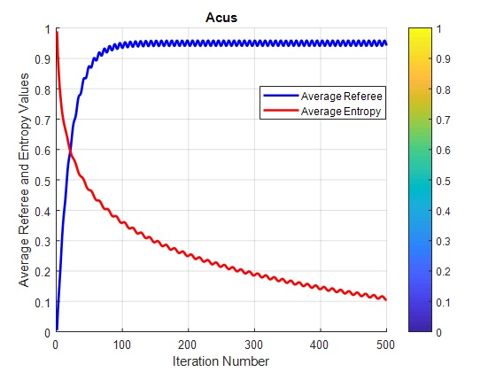 | 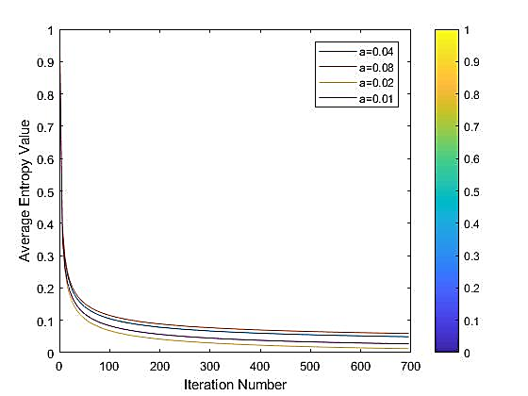
Acus | Bankwiring
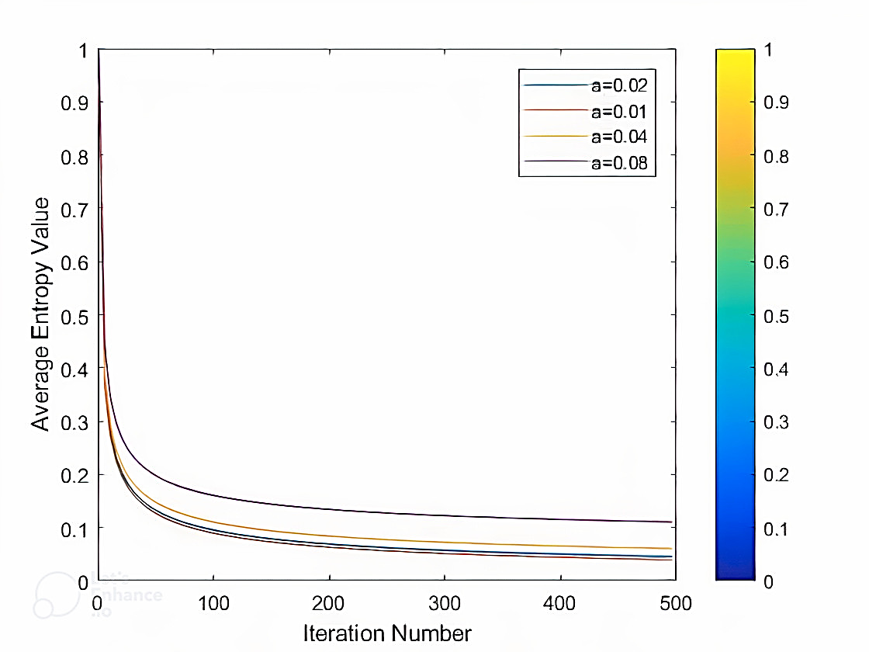 | 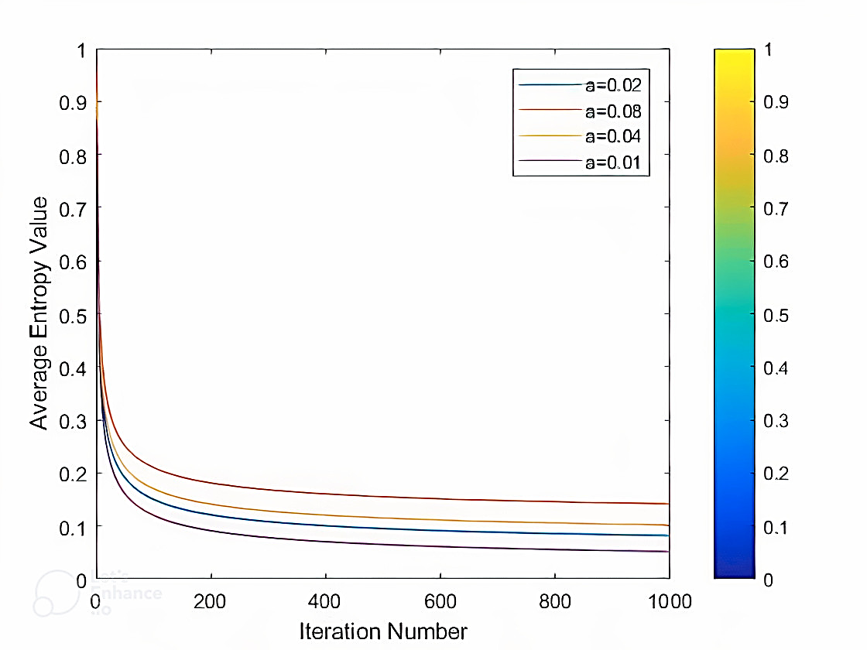
Florentine | Monastery
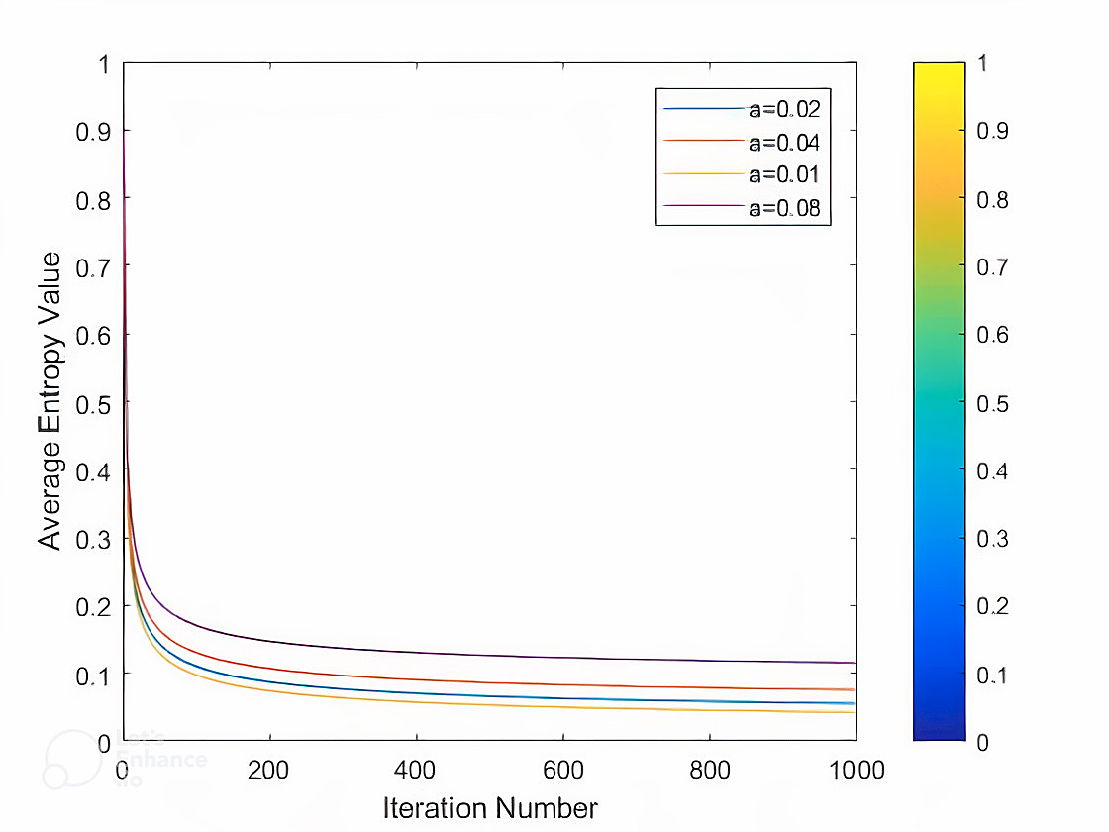
Tailorship

Figure 9: The plot of average entropy value versus iteration number for different learning rate.

Experiment II
This experiment aims to analyze the behavior of Algorithm 1 throughout the process of solution discovery. To achieve this objective, we generate plots depicting the Average Density at iteration k against the iteration number. The Average Density (k) values are normalized within the range of (0,1) by dividing each Average Density(k) value by the maximum local density weight for the respective graph. Notably, the Average Density(k), denoted as t, represents the average of the values of all overlapping communities identified up to iteration k. The outcomes of this experiment across various synthetic networks are illustrated in Figure 10. As depicted, the Average Density gradually converges towards the optimal partitioning for detecting overlapping communities. This observation indicates the algorithm's progressive identification of the appropriate overlapping community detection. Similar findings can be anticipated for alternative algorithms under evaluation.

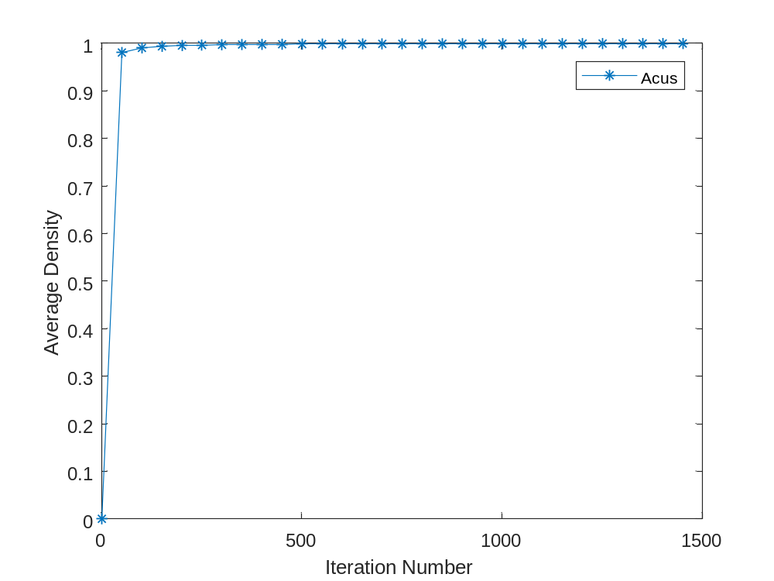
- Acus

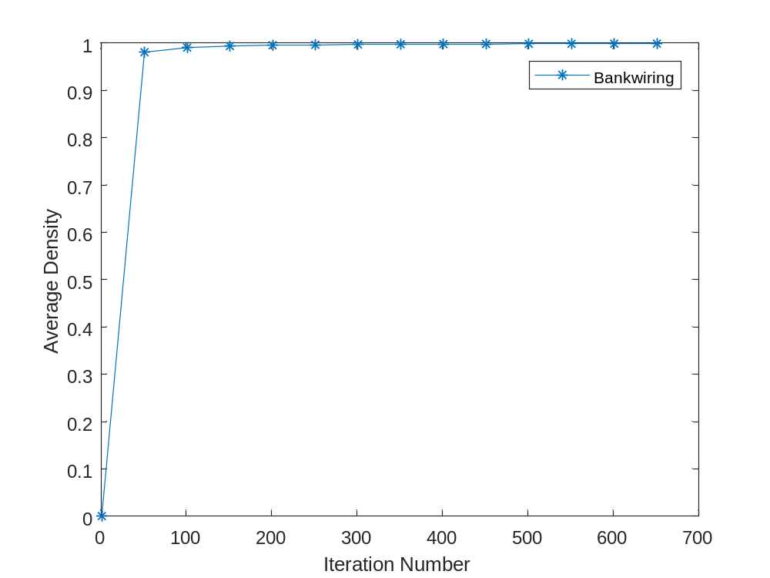
- Bankwiring

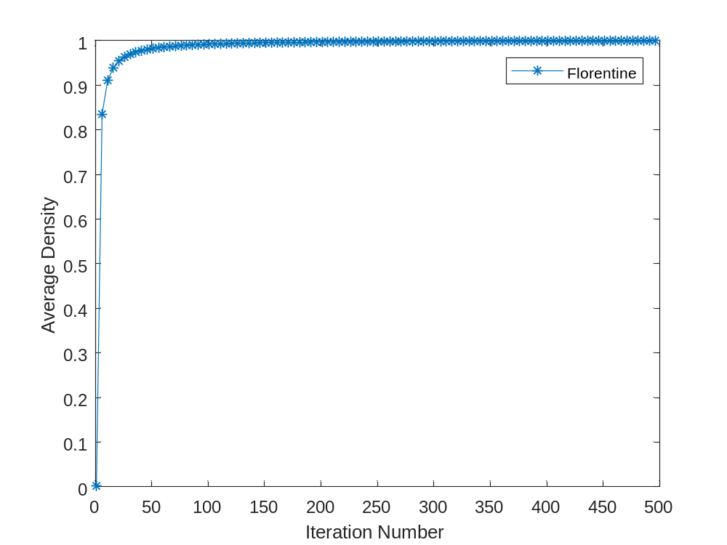

- Florantin

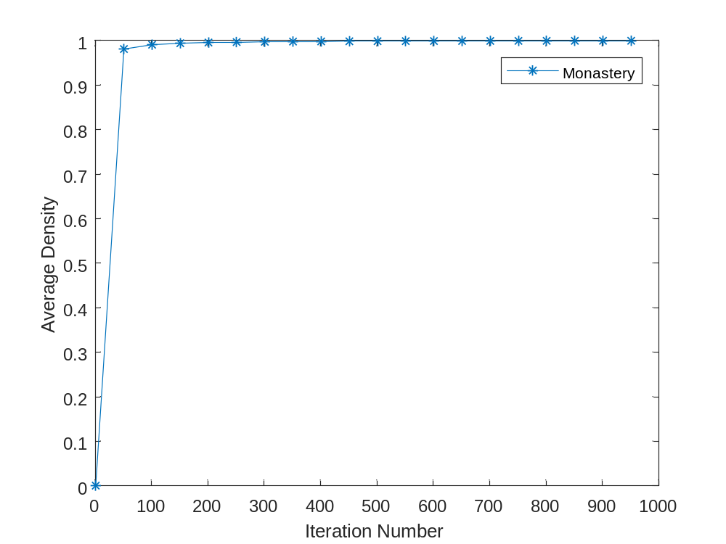
- Monastery
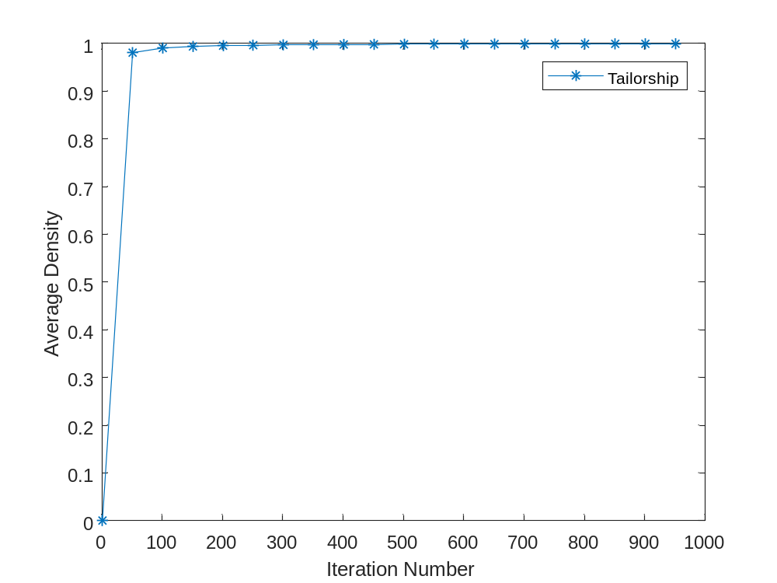
- Tailorship
Figure 10: The results for average density for real multilayer networks.

Experiment III
This experiment investigates the convergence behavior of the proposed CGG-OV algorithm compared to other algorithms in terms of Normalized Mutual Information for multilayer social networks (MNMI). To conduct this experiment, we explored the impact of different mixing parameters (μ) generated for multilayer LFR networks and their corresponding NMI values. Additionally, we studied the influence of the number of memberships for the overlapping nodes, which varied from 1 to 4 in these networks. The obtained results are depicted in Figure 11. From the results, it is observed that by varying the mixing parameters, the proposed algorithm successfully identifies overlapping communities for communities with lower mixing parameter rates. However, as the mixing parameter rate increases, leading to less clarity in the communities, all algorithms exhibit similar NMI values. The CGG-OV algorithm outperforms other algorithms due to its utilization of learning mechanisms. In other words, by employing learning automata and leveraging the objective function, the proposed algorithm effectively guides the discovery of overlapping communities in the networks.

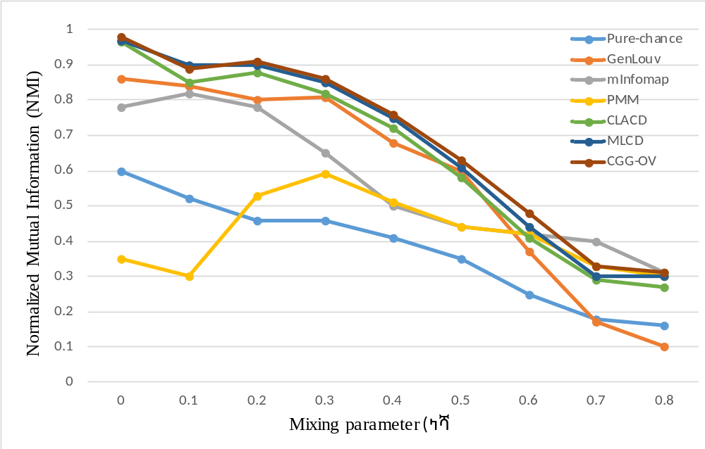
OM=1
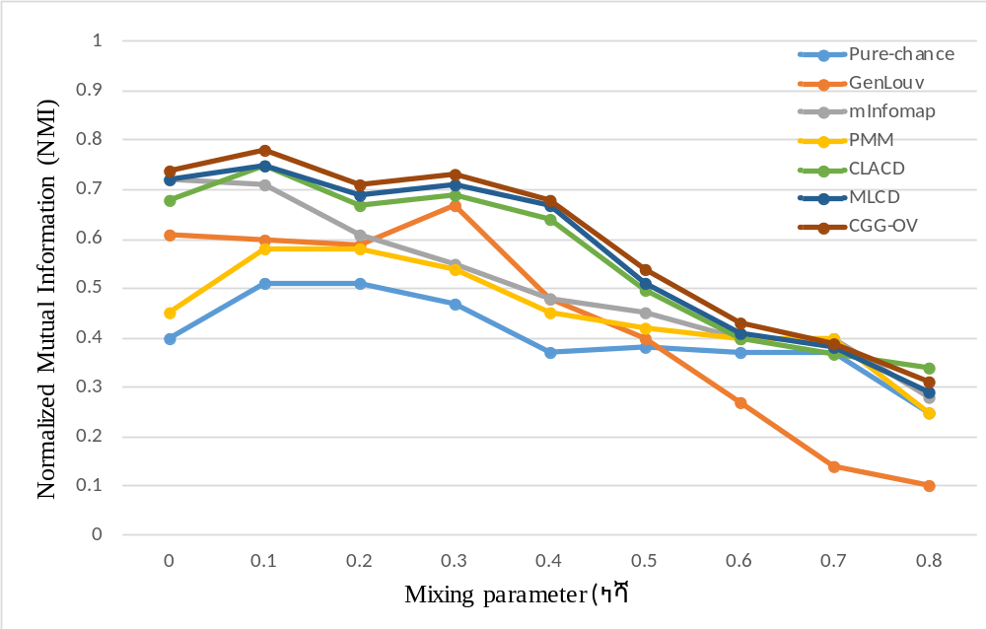
OM=2
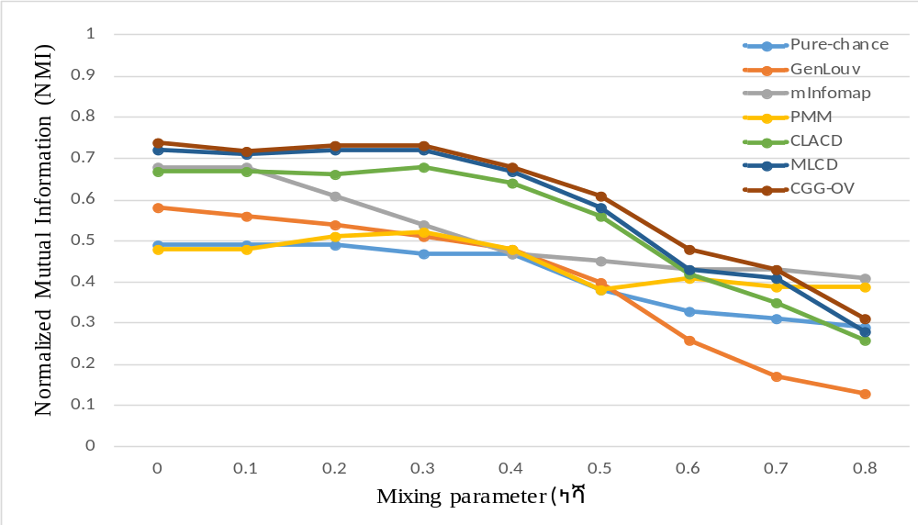
OM=3
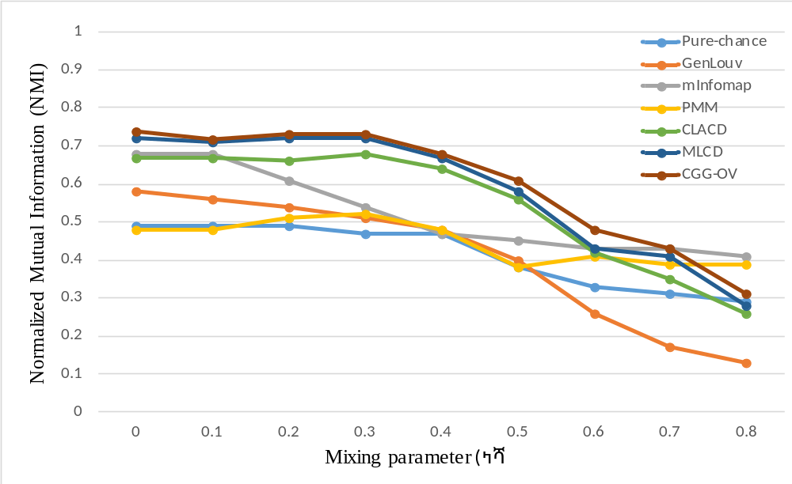
OM=4
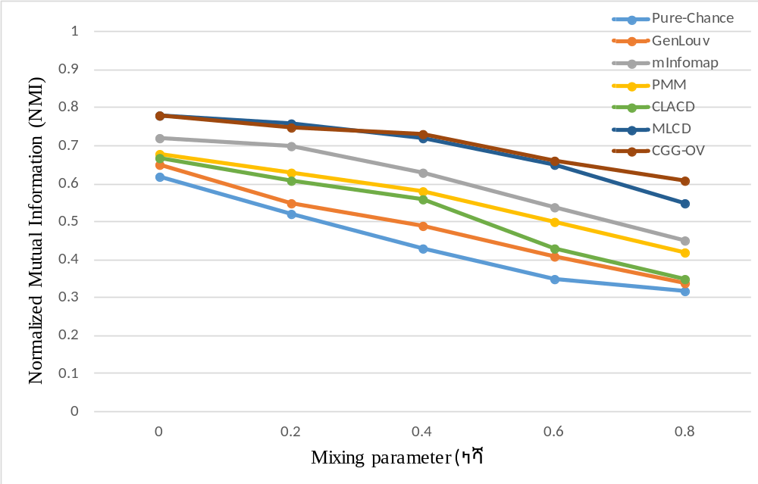
OM=5

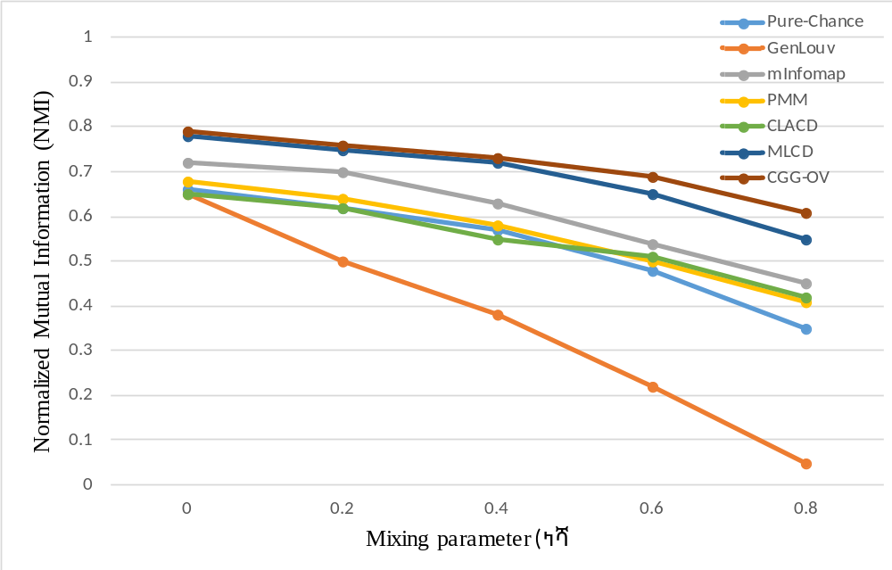
OM=6

Figure 11: Comparison of quality of the obtained results in terms of NMI on synthetic multilayer networks by varying number of memberships nodes OM= {1-6} in different mixing parameters.

Experiment V
This experiment was conducted to evaluate the proposed algorithm against other algorithms based on the MinMaxCut and Coverage criteria using a simulated dataset of multilayer networks. It is important to note that the MinMaxCut criterion indicates the degree of separability among overlapping multilayer communities, while the convergence criterion reflects the degree of association and cohesion within communities. The results, are depicted in Figure 12. From the results, one may conclude that, the proposed algorithm outperforms than other algorithms in terms of MinMaxCut and Coverage due to using learning automata and aid of explore and exploit mechanisms for finding overlapping communities. However, as the overlapping (OV) rate increases in synthetic networks, the results obtained by the proposed algorithm become similar to those of other algorithms due to the lack of clarity in the structure.

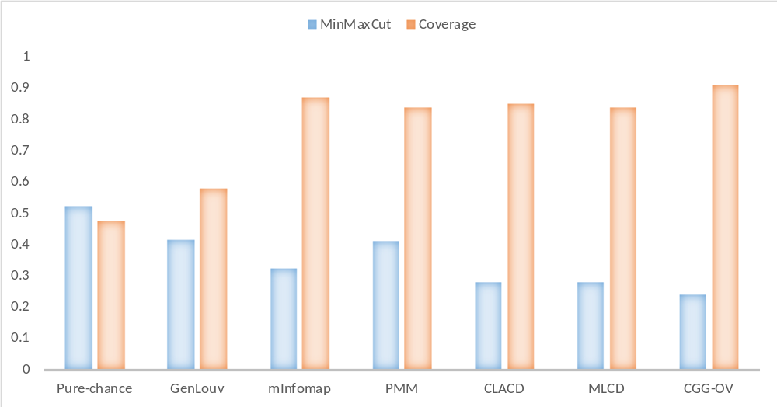
Ov=1
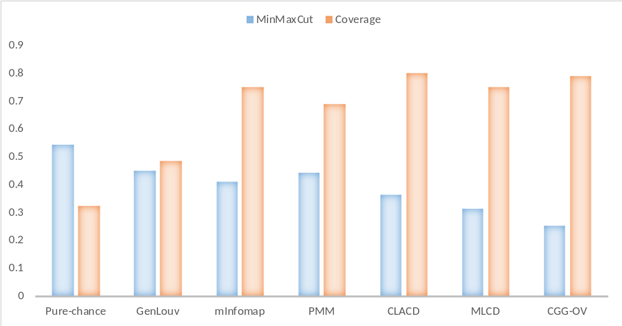
Ov =2
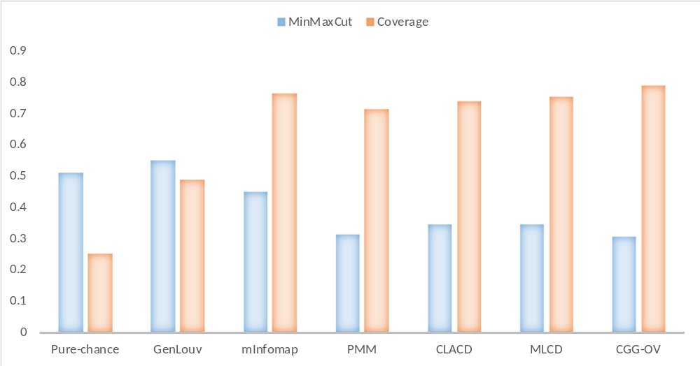
Ov=3
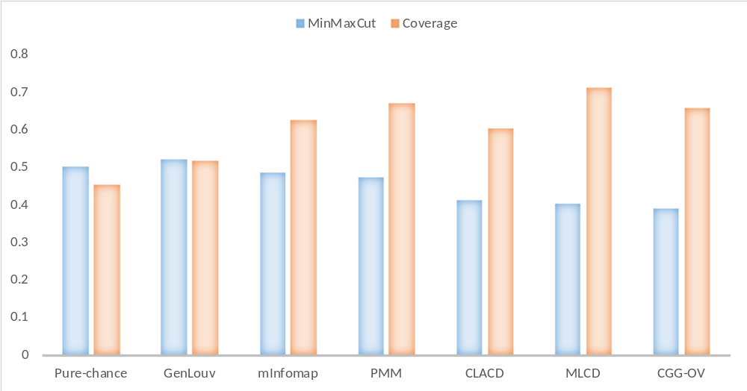
Ov=4
Figure 12: The obtained results for LFR networks in terms of MinMaxCut and Coverage.

Experiment VI
The aim of this experiment is to assess the performance of the CGG-OV algorithm in detecting overlapping communities based on modularity. The obtained results are compared with those of well-known algorithms for overlapping community detection, such as EMCD[70], GenLouv[71], mInfomap[72], PMM[73], CLACD[10] and MLCD[74]. The evaluation presented in the Table 2 demonstrates the effectiveness of various algorithms in maximizing modularity (Q) across real-world networks, with the performance assessed based on maximum (Max) and average (Avg) modularity. Among the algorithms, CGG-OV consistently outperforms others, achieving the highest Max modularity across most networks, including Florentine, Monastery, Bankwiring, Tailorship, and Acus. This indicates its strong capability in optimizing community structures. Additionally, CGG-OV exhibits robust Avg modularity scores, often matching or exceeding competitors like GenLouv and MLCD, highlighting its stability and reliability. In comparison, the baseline Pure-Chance (CGG) algorithm achieves significantly lower modularity values, emphasizing the improvements introduced by CGG-OV. GenLouv performs well in Avg modularity and is competitive in Max modularity but is slightly outperformed by CGG-OV in key networks. On the other hand, M-Infomap struggles with both Max and Avg modularity, particularly in networks like Acus and FF-Tw-Yt, where its values are notably lower than other algorithms. PMM, CLACD, and MLCD show mixed performance, with MLCD being competitive in some networks but generally unable to surpass CGG-OV. In network-specific trends, CGG-OV excels in larger, complex networks such as Friendfeed and FF-Tw-Yt, achieving the highest modularity scores, while maintaining consistent results across simpler networks like Florentine and Monastery. These findings suggest that CGG-OV is not only an improvement over its baseline but also a robust and effective alternative to other state-of-the-art methods. The CGG-OV algorithm provides superior performance, particularly its ability to maximize modularity across diverse networks, and position it as a reliable solution for community detection tasks. Moreover, the table provides evidence of the challenges faced by algorithms like M-Infomap and PMM, which tend to underperform in modularity metrics, further underscoring CGG-OV's advantages in this domain.
Table 2: Evaluation of CGG-OV algorithms on real-world networks based on maximum (Max) and average (Avg.) modularity.
Networks | Q | Pure-Chance(CGG) | GenLouv | M-Infomap | PMM | CLACD | MLCD | CGG-OV
Florentine | MAX | 0.411 | 0.530 | 0.548 | 0.456 | 0.546 | 0.591 | 0.592
 | AVG | 0.405 | 0.527 | 0.542 | 0.452 | 0.542 | 0.589 | 0.591
Monastery | MAX | 0.211 | 0.411 | 0.241 | 0.241 | 0.398 | 0.416 | 0.419
 | AVG | 0.204 | 0.402 | 0.238 | 0.238 | 0.397 | 0.413 | 0.418
Bankwiring | MAX | 0.371 | 0.526 | 0.919 | 0.40 | 0.512 | 0.526 | 0.526
 | AVG | 0.371 | 0.521 | 0.908 | 0.394 | 0.511 | 0.522 | 0.526
Tailorship | MAX | 0.141 | 0.358 | 0.174 | 0.174 | 0.491 | 0.358 | 0.515
 | AVG | 0.135 | 0.348 | 0.168 | 0.172 | 0.489 | 0.353 | 0.514
Acus | MAX | 0.324 | 0.633 | 0.826 | 0.372 | 0.799 | 0.633 | 0.801
 | AVG | 0.319 | 0.621 | 0.824 | 0.368 | 0.792 | 0.631 | 0.801
Ff-Tw-Yt | MAX | 0.390 | 0.497 | 0.286 | 0.238 | 0.488 | 0.497 | 0.498
 | AVG | 0.357 | 0.478 | 0.282 | 0.234 | 0.487 | 0.493 | 0.496
Friendfeed | MAX | 0.529 | 0.582 | 0.482 | - | 0.512 | 0.582 | 0.586
 | AVG | 0.523 | 0.578 | 0.478 | - | 0.508 | 0.581 | 0.581

Conclusion
In this paper, we propose a new model of Goore Game called Cellular Goore Game with multiple learning automaton in each cell (CGG). We extended the primary definitions of covergence in the theory of learning automata for Cellular Goore Game with multiple LAs and therefore based on the new definitions some studied were conducted. The analytical studies confirmed that the CGG with multiple LAs aid of $L_{R-I}$ learning algorithm is converges. Moreover, we have provided an entropy metric to study the players' behavior in each cell of the models and show that as the algorithm processed, the total entropy of the player's approach to zero. The numerical experiments were provided to support the theoretical results. To show the potential of this model in designing algorithms, an overlapping community detection problem called CGG-OV has been studied. Moreover, to show the superiority of the CGG-OV, the algorithm compared with six different algorithms which are two different learning automata based algorithms CLACD, Pure-chance and the obtained results shows the superiority of the proposed model in terms of Normalized mutual information and Modularity value.
The proposed model aims to tackle complex learning scenarios within specific application domains, resulting in inherently greater complexity compared to naïve cellular Goore Game model. However, a critical concern in the CGG-MLA model is its fully-parameterized system, stemming from multiple automata and independent learning rates. This aspect is particularly significant in convergence performance, an area that remains relatively unexplored within this context. The presence of learning automata in the CGG-MLA model suggests that a low learning rate may slow convergence, while a high rate can lead to local minima. Therefore, future work will focus on investigating new policies for tuning the learning rate of CGG-MLA through mathematical analysis.

Data Availability
The data underlying this article are available in the article and in its online supplementary material.

References
[1] Birgitt Schönfisch, André de Roos, “Synchronous and asynchronous updating in cellular automata,” Biosystems, vol. 51, no. 3, pp. 123–143, Sep. 1999.
[2] H. Beigy and M. R. Meybodi, “A mathematical framework for cellular learning automata,” Advances in Complex Systems, vol. 7, no. 03n04, pp. 295–319, 2004.
[3] J. Kari, “Reversibility of 2D cellular automata is undecidable,” Physica D: Nonlinear Phenomena, vol. 45, no. 1–3, pp. 379–385, 1990.
[4] S. Lakshmivarahan and M. A. L. Thathachar, “Bounds on the convergence probabilities of learning automata,” IEEE Transactions on Systems, Man, and Cybernetics-Part A: Systems and Humans, vol. 6, no. 11, pp. 756–763, 1976.
[5] H. Beigy and M. R. Meybodi, “Asynchronous cellular learning automata,” Automatica, vol. 44, no. 5, pp. 1350–1357, 2008.
[6] A. Rezvanian, A. M. Saghiri, S. M. Vahidipour, M. Esnaashari, and M. R. Meybodi, Recent Advances in Learning Automata, vol. 754. in Studies in Computational Intelligence, vol. 754. Cham: Springer International Publishing, 2018. doi: 10.1007/978-3-319-72428-7.
[7] H. Beigy and M. R. Meybodi, “Open synchronous cellular learning automata,” Advances in Complex Systems, vol. 10, no. 04, pp. 527–556, 2007.
[8] H. Beigy and M. R. Meybodi, “Cellular learning automata with multiple learning automata in each cell and its applications,” IEEE Transactions on Systems, Man, and Cybernetics, Part B (Cybernetics), vol. 40, no. 1, pp. 54–65, 2009.
[9] M. Esnaashari and M. R. Meybodi, “Irregular cellular learning automata,” IEEE transactions on cybernetics, vol. 45, no. 8, pp. 1622–1632, 2014.
[10] M. M. D. Khomami, A. Rezvanian, and M. R. Meybodi, “A new cellular learning automata-based algorithm for community detection in complex social networks,” Journal of Computational Science, vol. 24, pp. 413–426, Jan. 2018, doi: 10.1016/j.jocs.2017.10.009.
[11] M. Asnaashari and M. R. Meybodi, “Irregular cellular learning automata and its application to clustering in sensor networks,” in Proceedings of 15th Conference on Electrical Engineering (15th ICEE), Volume on Communication, Telecommunication Research Center, Tehran, Iran, 2007. Accessed: Mar. 11, 2024. [Online]. Available: https://www.academia.edu/download/31243400/Esnaashari-ICEE2007-Irreglular.pdf
[12] S. M. Vahidipour, M. R. Meybodi, and M. Esnaashari, “Adaptive Petri net based on irregular cellular learning automata with an application to vertex coloring problem,” Appl Intell, vol. 46, no. 2, pp. 272–284, Mar. 2017, doi: 10.1007/s10489-016-0831-x.
[13] M. Esnaashari and M. R. Meybodi, “Deployment of a mobile wireless sensor network with k-coverage constraint: a cellular learning automata approach,” Wireless Netw, vol. 19, no. 5, pp. 945–968, Jul. 2013, doi: 10.1007/s11276-012-0511-7.
[14] M. Esnaashari and M. R. Meybodi, “A cellular learning automata-based deployment strategy for mobile wireless sensor networks,” Journal of Parallel and Distributed Computing, vol. 71, no. 7, pp. 988–1001, 2011.
[15] A. M. Saghiri and M. R. Meybodi, “An approach for designing cognitive engines in cognitive peer-to-peer networks,” Journal of Network and Computer applications, vol. 70, pp. 17–40, 2016.
[16] A. M. Saghiri and M. R. Meybodi, “On expediency of closed asynchronous dynamic cellular learning automata,” Journal of computational science, vol. 24, pp. 371–378, 2018.
[17] B. J. Oommen and O.-C. Granmo, “Learning automata-based solutions to the Goore game and its applications,” Game Theory: Strategies, Equilibria, and Theorems, p. 183, 2009.
[18] M. M. D. Khomami, M. R. Meybodi, and R. Ameri, “Cellular goore game with application to finding maximum clique in social networks,” Journal of Computational Design and Engineering, vol. 9, no. 3, pp. 966–991, 2022.
[19] R. Ameri, M. R. Meybodi, and M. M. Daliri Khomami, “Cellular Goore Game and its application to quality-of-service control in wireless sensor networks,” The Journal of Supercomputing, pp. 1–48, 2022.
[20] R. Ameri and M. R. Meybodi, “An improved cellular goore game-based consensus protocol for blockchain,” Cluster Computing, pp. 1–26, 2024.
[21] M. M. D. Khomami, M. R. Meybodi, and A. Rezvanian, “Exploring social networks through stochastic multilayer graph modeling,” Chaos, Solitons & Fractals, vol. 182, p. 114764, 2024.
[22] M. M. D. Khomami, M. R. Meybodi, and A. Rezvanian, “A cellular goore game-based algorithm for finding the shortest path in stochastic multi-layer graphs,” The Journal of Supercomputing, vol. 81, no. 1, pp. 1–50, 2025.
[23] M. M. D. Khomami, M. R. Meybodi, and R. Ameri, “Cellular goore game with application to finding maximum clique in social networks,” Journal of Computational Design and Engineering, vol. 9, no. 3, pp. 966–991, 2022.
[24] H. Beigy and M. R. Meybodi, “Utilizing distributed learning automata to solve stochastic shortest path problems,” International Journal of Uncertainty, Fuzziness and Knowledge-Based Systems, vol. 14, no. 05, pp. 591–615, 2006.
[25] M. R. Mollakhalili Meybodi and M. R. Meybodi, “Extended distributed learning automata: An automata-based framework for solving stochastic graph optimization problems,” Appl Intell, vol. 41, no. 3, pp. 923–940, Oct. 2014, doi: 10.1007/s10489-014-0577-2.
[26] B. Moradabadi and M. R. Meybodi, “Wavefront cellular learning automata,” Chaos: An Interdisciplinary Journal of Nonlinear Science, vol. 28, no. 2, p. 021101, 2018.
[27] S. M. Vahidipour, M. R. Meybodi, and M. Esnaashari, “Cellular adaptive Petri net based on learning automata and its application to the vertex coloring problem,” Discrete Event Dynamic Systems, vol. 27, no. 4, pp. 609–640, 2017.
[28] K. S. Narendra and M. A. Thathachar, Learning automata: an introduction. Courier Corporation, 2012.
[29] A. Rezvanian, A. M. Saghiri, S. M. Vahidipour, M. Esnaashari, and M. R. Meybodi, “Cellular Learning Automata,” in Recent Advances in Learning Automata, vol. 754, in Studies in Computational Intelligence, vol. 754. , Cham: Springer International Publishing, 2018, pp. 21–88. doi: 10.1007/978-3-319-72428-7_2.
[30] Y. Zhao, W. Jiang, S. Li, Y. Ma, G. Su, and X. Lin, “A cellular learning automata based algorithm for detecting community structure in complex networks,” Neurocomputing, vol. 151, pp. 1216–1226, Mar. 2015, doi: 10.1016/j.neucom.2014.04.087.
[31] M. Mozafari, M. E. Shiri, and H. Beigy, “A cooperative learning method based on cellular learning automata and its application in optimization problems,” Journal of Computational Science, vol. 11, pp. 279–288, 2015.
[32] M. M. D. Khomami, A. Rezvanian, and M. R. Meybodi, “A new cellular learning automata-based algorithm for community detection in complex social networks,” Journal of computational science, vol. 24, pp. 413–426, 2018.
[33] M. Esnaashari and M. R. Meybodi, “A cellular learning automata based clustering algorithm for wireless sensor networks,” Sensor Letters, vol. 6, no. 5, pp. 723–735, 2008.
[34] M. Esnaashari and M. R. meybodi, “Irregular cellular learning automata and its application to clustiring in sensor network,” in Proceedings of 15th Conference on Electrical Engineering (15th ICEE), Tehran 2007.
[35] A. M. Saghiri and M. R. Meybodi, “Open asynchronous dynamic cellular learning automata and its application to allocation hub location problem,” Knowledge-Based Systems, vol. 139, pp. 149–169, 2018.
[36] M. Esnaashari and M. R. Meybodi, “Dynamic irregular cellular learning automata,” Journal of computational science, vol. 24, pp. 358–370, 2018.
[37] A. M. Saghiri and M. R. Meybodi, “A closed asynchronous dynamic model of cellular learning automata and its application to peer-to-peer networks,” Genet Program Evolvable Mach, vol. 18, no. 3, pp. 313–349, Sep. 2017, doi: 10.1007/s10710-017-9299-7.
[38] R. Vafashoar and M. R. Meybodi, “Reinforcement learning in learning automata and cellular learning automata via multiple reinforcement signals,” Knowledge-Based Systems, vol. 169, pp. 1–27, 2019.
[39] R. Vafashoar, H. Morshedlou, A. Rezvanian, and M. R. Meybodi, “Learning from Multiple Reinforcements in Cellular Learning Automata,” in Cellular Learning Automata: Theory and Applications, vol. 307, in Studies in Systems, Decision and Control, vol. 307. , Cham: Springer International Publishing, 2021, pp. 111–156. doi: 10.1007/978-3-030-53141-6_3.
[40] P. J. Mucha, T. Richardson, K. Macon, M. A. Porter, and J.-P. Onnela, “Community structure in time-dependent, multiscale, and multiplex networks,” science, vol. 328, no. 5980, pp. 876–878, 2010.
[41] J. Jia, P. Liu, X. Du, and Y. Zhang, “Multilayer social network overlapping community detection algorithm based on trust relationship,” Wireless Communications and Mobile Computing, vol. 2021, pp. 1–14, 2021.
[42] Z. Zhu, G. Yuan, T. Zhou, and J. Cao, “Community Detection for Heterogeneous Multiple Social Networks,” IEEE Transactions on Computational Social Systems, 2024, Accessed: Jan. 22, 2025. [Online]. Available: https://ieeexplore.ieee.org/abstract/document/10552103/
[43] P. Wang and W. K. V. Chan, “A multilayer community detection algorithm based on aggregation in social Internet of things,” in 2022 7th International Conference on Intelligent Computing and Signal Processing (ICSP), IEEE, 2022, pp. 610–614. Accessed: Jan. 22, 2025. [Online]. Available: https://ieeexplore.ieee.org/abstract/document/9778307/
[44] S. Rani and M. Kumar, “Ranking community detection algorithms for complex social networks using multilayer network design approach,” International Journal of Web Information Systems, vol. 18, no. 5/6, pp. 310–341, 2022.
[45] R. Kashef, “Detecting Overlapping Communities in Social Networks Using A Modified Segmentation by Weighted Aggregation Approach,” in International Conference on Data Science, E-learning and Information Systems 2021, Ma’an Jordan: ACM, Apr. 2021, pp. 60–69. doi: 10.1145/3460620.3460632.
[46] J. Zhang, F. Wang, and J. Zhou, “Community detection based on nonnegative matrix tri-factorization for multiplex social networks,” Journal of Complex Networks, vol. 12, no. 2, p. cnae012, 2024.
[47] X. Huang, D. Chen, T. Ren, and D. Wang, “A survey of community detection methods in multilayer networks,” Data Min Knowl Disc, vol. 35, no. 1, pp. 1–45, Jan. 2021, doi: 10.1007/s10618-020-00716-6.
[48] W. Liu, T. Suzumura, H. Ji, and G. Hu, “Finding overlapping communities in multilayer networks,” PloS one, vol. 13, no. 4, p. e0188747, 2018.
[49] L. Huang, C.-D. Wang, and H.-Y. Chao, “oComm: Overlapping community detection in multi-view brain network,” IEEE/ACM Transactions on Computational Biology and Bioinformatics, vol. 18, no. 4, pp. 1582–1595, 2019.
[50] R. Dong, J. Yang, and Y. Chen, “Overlapping community detection in weighted temporal text networks,” IEEE Access, vol. 8, pp. 58118–58129, 2020.
[51] S. Gupta and P. Kumar, “An overlapping community detection algorithm based on rough clustering of links,” Data & Knowledge Engineering, vol. 125, p. 101777, 2020.
[52] X. Yang, L. Cui, and Y. Liu, “Application Analysis of Overlapping Community Detection Algorithms for Multidimensional Network Big Data and IoT,” Wireless Communications and Mobile Computing, vol. 2022, 2022, Accessed: Feb. 11, 2024. [Online]. Available: https://www.hindawi.com/journals/wcmc/2022/1172186/
[53] X. Gao, Q. Zheng, F. A. N. Verri, R. D. Rodrigues, and L. Zhao, “Particle Competition for Multilayer Network Community Detection,” in Proceedings of the 2019 11th International Conference on Machine Learning and Computing, Zhuhai China: ACM, Feb. 2019, pp. 75–80. doi: 10.1145/3318299.3318320.
[54] H. Li, W. Xu, C. Qiu, and J. Pei, “Fast Markov clustering algorithm based on belief dynamics,” IEEE Transactions on Cybernetics, 2022, Accessed: Feb. 09, 2024. [Online]. Available: https://ieeexplore.ieee.org/abstract/document/9693335/
[55] S. Song, Y. Feng, W. Xu, H.-J. Li, and Z. Wang, “Evolutionary prisoner’s dilemma game on signed networks based on structural balance theory,” Chaos, Solitons & Fractals, vol. 164, p. 112706, 2022.
[56] H.-J. Li et al., “Characterizing the fuzzy community structure in link graph via the likelihood optimization,” Neurocomputing, vol. 512, pp. 482–493, 2022.
[57] H. Beigy and M. R. Meybodi, “A New Distributed Learning Automata Based Algorithm For Solving Stochastic Shortest Path Problem.,” in JCIS, Citeseer, 2002, pp. 339–343.
[58] S. M. Vahidipour, M. R. Meybodi, and M. Esnaashari, “Finding the shortest path in stochastic graphs using learning automata and adaptive stochastic petri nets,” International Journal of Uncertainty, Fuzziness and Knowledge-Based Systems, vol. 25, no. 03, pp. 427–455, 2017.
[59] B. Anari, J. A. Torkestani, and A. M. Rahmani, “Automatic data clustering using continuous action-set learning automata and its application in segmentation of images,” Applied Soft Computing, vol. 51, pp. 253–265, 2017.
[60] A. Wheeldon, R. Shafik, T. Rahman, J. Lei, A. Yakovlev, and O.-C. Granmo, “Learning automata based energy-efficient AI hardware design for IoT applications,” Philosophical Transactions of the Royal Society A, vol. 378, no. 2182, p. 20190593, 2020.
[61] A. A. Rahmanian, M. Ghobaei-Arani, and S. Tofighy, “A learning automata-based ensemble resource usage prediction algorithm for cloud computing environment,” Future Generation Computer Systems, vol. 79, pp. 54–71, 2018.
[62] J. A. Torkestani and M. R. Meybodi, “An intelligent backbone formation algorithm for wireless ad hoc networks based on distributed learning automata,” Computer Networks, vol. 54, no. 5, pp. 826–843, 2010.
[63] A. M. Saghiri and M. R. Meybodi, “An adaptive super-peer selection algorithm considering peers capacity utilizing asynchronous dynamic cellular learning automata,” Applied Intelligence, vol. 48, no. 2, pp. 271–299, 2018.
[64] A. Rezvanian and M. R. Meybodi, “Finding minimum vertex covering in stochastic graphs: a learning automata approach,” Cybernetics and Systems, vol. 46, no. 8, pp. 698–727, 2015.
[65] J. Rosebush, AP® Calculus AB & BC Crash Course Book+ Online. Research & Education Assoc., 2016.
[66] M. A. L. Thathachar and M. T. Arvind, “Solution of Goore game using modules of stochastic learning automata,” Journal of the Indian Institute of Science, vol. 77, no. 1, p. 47, 2013.
[67] D. Rhouma and L. B. Romdhane, “An efficient algorithm for community mining with overlap in social networks,” Expert Systems with applications, vol. 41, no. 9, pp. 4309–4321, 2014.
[68] Y. Zhang, P. Fitch, M. P. Vilas, and P. J. Thorburn, “Applying multi-layer artificial neural network and mutual information to the prediction of trends in dissolved oxygen,” Frontiers in Environmental Science, vol. 7, p. 46, 2019.
[69] M. De Domenico, M. A. Porter, and A. Arenas, “MuxViz: a tool for multilayer analysis and visualization of networks,” Journal of Complex Networks, vol. 3, no. 2, pp. 159–176, 2015.
[70] R. Interdonato, A. Tagarelli, D. Ienco, A. Sallaberry, and P. Poncelet, “Local community detection in multilayer networks,” Data Mining and Knowledge Discovery, vol. 31, no. 5, pp. 1444–1479, 2017.
[71] I. S. Jutla, L. G. Jeub, and P. J. Mucha, “A generalized Louvain method for community detection implemented in MATLAB,” URL http://netwiki. amath. unc. edu/GenLouvain, 2011.
[72] M. De Domenico, A. Lancichinetti, A. Arenas, and M. Rosvall, “Identifying modular flows on multilayer networks reveals highly overlapping organization in interconnected systems,” Physical Review X, vol. 5, no. 1, p. 011027, 2015.
[73] L. Tang, X. Wang, and H. Liu, “Uncoverning groups via heterogeneous interaction analysis,” in 2009 Ninth IEEE International Conference on Data Mining, IEEE, 2009, pp. 503–512.
[74] M. R. Shahmoradi, M. Ebrahimi, Z. Heshmati, and M. Salehi, “Multilayer overlapping community detection using multi-objective optimization,” Future Generation Computer Systems, vol. 101, pp. 221–235, 2019.

